C:\Documents and Settings\julia.powell\My Documents\IHO TSMAD\S100-0 main\IHO S-100 Main Oct 1 2007.doc © ISO/IEC 2007 – All rights reservedISO-IEC_ 63Complementary elementIntroductory element — Main elementÉlément introductif — Élément central — Élément complémentaireIntroductory element — Main element — Complementary elementE2007-10-2 ISO/IECISO/IEC     2007 ISO/IEC ISO/IEC _(E).        2Heading 2Heading 1    02 STD Version 2.1c20   4             INTERNATIONAL HYDROGRAPHIC ORGANIZATION



**IHO GEOSPATIAL STANDARD**

**S-98 Specification for Data Product Interoperability in S-100 Navigation Systems**

**Draft Version 0.3**

**2018-07-08**

**Special Publication No. S-98**

Published by the

International Hydrographic Organization

MONACO

**Revision History**

Changes to this Specification are coordinated by the IHO S-100 Working Group. New editions will be made available via the IHO web site. Maintenance of the Specification shall conform to IHO Technical Resolution 2/2007 (revised 2010).

|  |  |  |  |
| --- | --- | --- | --- |
| Version Number | Date | Author | Purpose |
| 0.1 | 2017-07-31 | EM, RM | First draft |
| 0.2 | 2017-12-12 | RM, EM | Changes from interoperability workshop and TSM5 |
| 0.3 | 2018-07-08 | EM, RM | Edits from March 2018 review comments  Updates for conformance to S-100 Edition 4.0.0, ISO 19115-1, and 19115-3. Removed metadata items not used by S-98 from the metadata documentation tables. |
|  |  |  |  |
|  |  |  |  |
|  |  |  |  |
|  |  |  |  |
|  |  |  |  |
|  |  |  |  |
|  |  |  |  |
|  |  |  |  |

Contents

1 Overview 1

1.1 Introduction 1

1.2 References 1

1.3 Terms, definitions and abbreviations 2

1.4 General Data Product Description 7

1.5 Catalogue specification metadata 7

1.6 Implementation phases 9

2 Specification Scopes 9

3 Interoperability Catalogue Identification 9

4 Data Content and structure 10

4.1 Introduction 10

4.2 Overview of approach to implementing interoperability 10

4.3 Application Schema 13

4.4 Interoperability Catalogue 14

4.5 Filters 22

4.6 Interoperability Levels 23

4.7 UML model documentation tables 27

4.8 Application schema for higher-level catalogues (informative) 34

4.9 Additional documentation tables for advanced interoperability catalogues (informative) 39

4.10 Processing overview for catalogues with Levels 3 and 4 (Informative) 45

5 Coordinate Reference Systems (CRS) 45

6 Data Quality 45

7 Performance Standards for ECDIS 46

8 How to make product specifications interoperable 46

8.1 Duplicated features 46

8.2 Geometry 47

8.3 Display of text 49

8.4 Skin-of-the-earth replacement 49

8.5 Hierarchy of data 49

8.6 New datasets 50

8.7 Dataset loading and unloading 50

8.8 New data products 50

8.9 Metadata 51

9 Maintenance 51

9.1 Maintenance and Update Frequency 51

9.2 Typical Sources of Change 51

9.3 Production Process 51

9.4 Management of FC and PC updates 52

9.5 PS updates other than FC/PC 53

9.6 Unpredictable PS updates 53

9.7 Additional data products to be defined in catalogue 53

9.8 Backward compatibility 53

10 Portrayal 54

10.1 Display of significant features 54

10.2 Display of significant features - switching to original 55

10.3 Portrayal distinguishability - colour set-asides 55

10.4 Day/night/dusk modes 55

10.5 Impacts on viewing groups 56

10.6 Impacts on portrayal catalogues 56

10.7 Meta-features 56

10.8 Display of text 57

10.9 Skin-of-the earth replacement 57

10.10 Blended portrayals 58

10.11 Hierarchy of data 58

10.12 Pick reports 58

10.13 User control over loaded set 59

10.14 User control over interoperation level 59

11 Data Product format (encoding) 60

11.1 Introduction 60

11.2 Unknown Attribute Values 60

11.3 XML schemas 60

12 Data Product Delivery 67

12.1 Introduction 67

12.2 Interoperability Catalogue product 69

12.3 Support Files 69

12.4 Exchange Catalogue 70

12.5 Encryption and authentication 70

12.6 Updating the Interoperability Catalogue 71

13 Metadata 73

13.1 Introduction 73

13.2 Language 73

13.3 Interoperability Catalogue Metadata elements 74

14 Processing model 87

14.1 Overview of processing 87

14.2 Processing model for basic interoperability 88

14.3 Processing model for advanced interoperability (Informative) 91

15 User interaction constraints and expectations 93

15.1 Structured interoperation 93

15.2 Customization - user level 93

15.3 Support Human-Centred Design 93

15.4 Interoperation requirements for product specifications 94

15.5 Support different levels of interoperation 95

15.6 User control over loaded set 95

15.7 User control over interoperation level 96

15.8 Priority overrides for user-specified settings 96

16 Data Encoding Guide 97

16.1 Introduction 97

16.2 General encoding notes 97

16.3 Unknown Attribute Values 97

16.4 Element S100_IC_DisplayPlane 97

16.5 Element S100_IC_DrawingInstruction 98

16.6 Element S100_IC_Feature 98

16.7 Element S100_IC_InteroperabilityCatalogue 98

16.8 Element S100_IC_DisplayPlane 98

16.9 Element S100_IC_PredefinedCombination 99

16.10 Element S100_IC_SuppressedFeatureLayer 99

17 Normative Implementation Guidance 99

17.1 Reduce demand on user attention - display adjustment 99

17.2 Reduce demands on user attention - avoid text overload 99

17.3 Support for novice users 100

17.4 Reduce demands on user attention - planning and monitoring modes 100

17.5 Interoperability and data coverage 100

17.6 Other significant information 100

17.7 Phased implementation 100

18 Interoperability Catalogue Schema Documentation 101

19 Feature Catalogue 101

20 Portrayal Catalogue 101

# Overview

Mariners and other users will receive different S-100-based data products, each providing one or more information layers, and will often need to view some of the information layers simultaneously on a S-100 compatible ECDIS as well as in other ship and shore-based scenarios. Other data layers such as radar overlays are also expected to be present. The smooth interoperation and harmonized user-friendly graphical presentations of these various products is therefore necessary. The rules for interoperation and harmonized graphical presentations of S-100 data products are contained in an *interoperability catalogue*, which is a kind of meta-product that describes how specified products are to be used and displayed simultaneously.

This specification describes the structure, usage, and rules for development of interoperability catalogues that can be used by systems to guide the simultaneous use and display of two or more S-100 based data products.

Within the specification four levels of interoperability are defined, however, only Levels 1 and 2 are specified in full. The remaining two levels will be finalized at a later date when the implementation of Levels 1 and 2 has been tested further.

## Introduction

This specification should be considered as a minimum requirement of what interoperability functions an ECDIS, that is S-100 compatible, should be able to perform. Functionality beyond this specification may be provided by S-100 compatible ECDIS, including functions allowing users to specify their own interoperability rules. This specification is intended for ECDIS and Navigational Systems, however the same ideas may be reused elsewhere, but should then be defined as a separate specification.

This version of the specification was developed taking into account the product specifications listed in the table below. A catalogue conforming to this version of the specification may potentially also include similar product specifications, such as S-123 (Marine Radio Services), but the ability to include such other specifications must be evaluated on a case-by-case basis.

Table 1. S-100 product specifications considered for this version of the specification

| **Specification No.** | **Title** |
| --- | --- |
| S-101 | Electronic Navigational Chart (ENC) / *Cartes électroniques de navigation* |
| S-102 | Bathymetric Surface / *Surface bathymétrique* |
| S-104 | Water Level Information for Surface Navigation / *Information de hauteur d’eau pour la navigation de surface* |
| S-111 | Surface currents / *Courants de surface* |
| S-122 | Marine Protected Areas / *Aires marines protégées* |
| S-124 | Navigational warnings / *Avertissements de navigation* |
| S-411 | Sea Ice (WMO-IOC Joint Technical Commission for Oceanography and Marine Meteorology [JCOMM])  *Glace de mer (Commission technique mixte OMM-COI pour l’océanographie et la météorologie marine [JCOMM])* |
| S-412 | Met-ocean forecasts (JCOMM)  *Prévisions météo-océanographiques (JCOMM)* |

## References

RFC 2141 URN Syntax. Internet Engineering Task Force (IETF), May 1997.

S-100 IHO Universal Hydrographic Data Model  
S-101 Electronic Navigational Chart (ENC)  
S-102 Bathymetric Surface

S-104 Water Level Information for Surface Navigation  
S-111 Surface currents  
S-122 Marine Protected Areas  
S-124 Navigational warnings  
S-411 Sea Ice (JCOMM)  
S-412 Met-ocean forecasts (JCOMM)  
IMO MSC.1/Circ.1512 Guideline on Software Quality Assurance and Human-Centred Design for e-Navigation

ISO 19115-1 ISO 19115-1:2014, Geographic information – Metadata – Part 1 - Fundamentals. As amended by Amendment 1, 2018.

ISO 19115-3 ISO/TS 19115-3:2016, Geographic information - Metadata - XML schema implementation for fundamental concepts.

XPath XML Path Language (XPath) 3.1 - W3C Recommendation 21 March 2017 (World-Wide Web Consortium – W3C). URL: https://www.w3.org/TR/2017/REC-xpath-31-20170321/ (Retrieved 2017-12-08)

## Terms, definitions and abbreviations

### Use of Language

Within this document:

1. “Must” indicates a mandatory requirement.

“Should” indicates an optional requirement, that is the recommended process to be followed, but is not mandatory.

1. “May” means “allowed to” or “could possibly”, and is not mandatory.

### Terms and Definitions

Alarm

(MSC.302/A) a high-priority alert. Condition requiring immediate attention and action by the bridge team, to maintain the safe navigation of the ship.

Alert

(MSC.302/A) announcement of abnormal situations and conditions requiring attention. Alerts are divided in four priorities: emergency alarms, alarms, warnings and cautions. An alert provides information about a defined state change in connection with information about how to announce this event in a defined way to the system and the operator.

Caution

(MSC.302/A) lowest priority of an alert. Awareness of a condition which does not warrant an alarm or warning condition, but still requires attention out of the ordinary consideration of the situation or of given information.

Complex Line Styles

Lines that are themselves symbols, or that have symbols interlaced. Examples of a line as a symbol are a submerged pipeline LC(PIPSOL05), or the T T T lines indicating the inside of an area LC(ENTRES51). A simple or complex line may have a symbol interlaced, such as an anchor for anchorage area LC(ACHARE51).

Data Coverage (feature)

A geographical area that describes the coverage and extent of spatial types. The meta feature **Data Coverage** encodes the area covered by data within the dataset.

Dataset

An identifiable collection of data

NOTE A dataset may be a smaller grouping of data which, though limited by some constraint such as spatial extent or feature type is located physically within a larger dataset. Theoretically, a dataset may be as small as a single feature contained within a larger dataset. A hardcopy map or chart may be considered a dataset.

Display Category

The IMO ECDIS Performance Standard establishes three display categories for the presentation of SENC features Display base: always on the display. Standard display: the SYSTEM default display. Other: all other features in the SENC.

Display Priority

Hierarchy to determine which feature is to be displayed when two features overlap. Priority 2 overwrites 1.

Electronic Chart Display and Information System (ECDIS)

A navigation information system which with adequate back-up arrangements can be accepted as complying with the up-to-date chart required by regulations V/19 and V/27 of the 1974 SOLAS Convention, as amended, by displaying selected information from a system electronic navigational chart (SENC) with positional information from navigation sensors to assist the Mariner in route planning and route monitoring, and if required display additional navigation-related information.

ECDIS Chart 1

An ECDIS version of INT 1, including all symbols, line styles and colour coding used for chart presentation. Intended for the Mariner to both familiarize himself with ECDIS and to look up specific symbols.

Electronic Chart System (ECS)

Navigation information system that electronically displays vessel position and relevant nautical chart data and information from the ECS database on a display screen, but does not meet all IMO requirements for ECDIS, and does not satisfy SOLAS Chapter V requirement to carry a navigational chart.

Electronic Navigational Chart (ENC)

The dataset, standardized as to content, structure and format, issued for use with ECDIS by or on the authority of a Government authorized Hydrographic Office or other relevant government institution, and conform to IHO standards. The ENC contains all the chart information necessary for safe navigation and may contain supplementary information in addition to that contained in the paper chart which may be considered necessary for safe navigation.

Feature

Abstraction of real world phenomena

NOTE: A feature may occur as a type or an instance. The terms “feature type” or “feature instance” should be used when only one is meant

EXAMPLE: The feature instance named “Eiffel Tower” may be classified with other phenomena into a feature type “tower.”

Geometric Primitive

geometric object representing a single, connected, homogeneous element of geometry

NOTE: Geometric primitives are non-decomposed objects that present information about geometric configuration. They include points, curves, surfaces

Human-Centred Design (HCD)

An approach to system design and development that aims to make interactive systems more usable by focussing on the use of the system; applying human factors, ergonomics and usability knowledge and techniques.

Indication

Visual indication giving information about the condition of a system or equipment.

Interoperability

The capability of controlling interactions, especially of visual appearance and information content, between two or more S-100 data products displayed simultaneously on the same screen.

Minimum Display Scale

The smallest value of the ratio of the linear dimensions of features of a dataset presented in the display and the actual dimensions of the features represented (smallest scale) of the scale range of the dataset.

Maximum Display Scale

The larger value of the ratio of the linear dimensions of features of a dataset presented in the display and the actual dimensions of the features represented (largest scale) of the scale range of the dataset.

Navigation System

Navigation information system that electronically displays vessel position and relevant nautical chart data and information from a database on a display screen. ECDIS and ECS are two types of Navigation System.

No symbol Feature

In some cases, the database contains information that is not intended for display. (An example might be a general area such as “Great Australian Bight” which would be available for an answer to cursor interrogation of the sea area.)

Opaque fill

The background is completely filled with the colour fill. (For example, depth area). The point and line SENC features may be overwritten. The raw RADAR image is a special case of opaque fill which overwrites all other features expect those with "priority over radar" (OVERRADAR).

OVERRADAR

A priority designation that instructs the display to put the object's presentation over radar information. (Adapted from S-52 edition 6.0.0.)

Pattern fill

A method of identifying areas by large, faintly coloured symbols well spaced out across the area. A pattern spacing algorithm ensures that the pattern symbols are visible without being so dense as to cause clutter. Used to ensure pattern symbols are always visible at any display scale.

RADAR

A method, system or technique of using beamed, reflected, and timed radio waves for detecting, locating, or tracking objects, and for measuring altitudes. The electronic equipment or apparatus used to generate, transmit, receive, and usually, to display radio scanning or locating waves; a radar set. The name 'radar' is derived from the words radio detecting and ranging. (S-32)

Radar Priority

The IMO ECDIS Performance Standard requires that radar can be switched off with a "single action control" in order to see SENC and Mariners info clearly. However certain other info, such as planned route, safety contour, coastline should always be written over the radar.

Radar Transparency

A method of varying the transparency of radar in a continuous progression from no radar to a totally opaque radar overlay, by merging the radar colour with the colour of the feature it overlays at each pixel. [PS]

Scale minimum (SCAMIN)

The smallest scale at which a feature is displayed (For example, a minor light, SCAMIN of 1:45,000, would not be displayed at a scale of 1:90,000).

System Electronic Navigational Chart (SENC)

In ECDIS means a database, in the manufacturer’s internal ECDIS format, resulting from the loss-less transformation of the entire ENC contents and its updates. It is this database that is accessed by ECDIS for the display generation and other navigational functions, and is equivalent to an up-to-date paper chart. The SENC may also contain information added by the mariner and information from other sources.

Simple Line Styles

Solid lines, dots and dashes.

Skin of the earth

A subset of the geographic (geo) features that must create a complete non-overlapping coverage of the area of data coverage of an ENC dataset.

Software Quality Assurance (SQA)

A set of processes that ensures software meets and complies with required quality specifications. Designated SQA processes align with a system design life cycle.

SYSTEM

When used without a qualifying term, the combination of computer hardware, operating system, application software, and interfaces that constitute the platform on which S-100 and related data are processed for viewing or other use by a human end-user.

Note: “System” is often used with a qualifying term, e.g., “Electronic Chart Display and Information System”, “Electronic Charting System”, “operating system”, etc.

Usability Testing (UT)

Evaluation methods and techniques used to support Human-Centred Design (HCD) and used for the purpose of increasing the usability of a system.

### Abbreviations

ARPA Automatic Radar Plotting Aid

AIS Automatic Identification System

AIS ASM AIS Application Specific Messages

CIRM Comité International Radio-Maritime

CRS Coordinate Reference System

DCEG Data Classification and Encoding Guide

DQ Data Quality

ECDIS Electronic Chart Display and Information System

ECS Electronic Chart System

ENC Electronic Navigational Chart

EPSG European Petroleum Survey Group

FC Feature Catalogue

HCD Human-Centred Design

IEC International Electrotechnical Commission

IC Interoperability Catalogue

IHO International Hydrographic Organization

IMO International Maritime Organization

ISO International Organization for Standardization

GFM General Feature Model

JCOMM WMO-IOC Joint Technical Commission for Oceanography and Marine Meteorology

MPA Marine Protected Area

MRN Maritime Resource Name

MRS Marine Radio Services

OEM Original Equipment Manufacturer

OGC Open Geospatial Consortium

PC Portrayal Catalogue

PDC PreDefined Combination

PS Product Specification

SENC System Electronic Navigational Chart

SOLAS Safety of Life at Sea (Convention)

SQA Software Quality Assurance

UI User Interface

URI Uniform Resource Identifier

URL Uniform Resource Locator

URN Uniform Resource Name

XML eXtensible Markup Language

XSD XML Schema Definition (a format for formally describing the elements in an XML document)

XSL eXtensible Stylesheet Language

XSLT XSL Transformations

## General Data Product Description

Title: S-98 Specification for Data Product Interoperability in S-100 Navigation Systems

Abstract: An interoperability catalogue is a collection of rules that control visual and other interactions between S-100 based data products conforming to different product specifications. This interoperability catalogue is intended to be used by navigation systems where datasets conforming to two or more S-100 based product specifications are used and viewed simultaneously.

Acronym: S-98; IC; S-100 IC

Content: Catalogues conforming to this specification contain interoperability rules for the described group of S-100 based product specifications applicable to ECDIS systems.

Spatial Extent: Global coverage of maritime areas.

**East Bounding Longitude:** 180°

**West Bounding Longitude:** -180°

**North Bounding Latitude:** 90°

South Bounding Latitude: -90°

Purpose: The purpose of an interoperability catalogue is to de-clutter displays, reduce information overload, resolve conflicts, and improve the overall quality and clarity of information presentation to mariners when multiple S-100 based data products are simultaneously displayed on-screen.

## Catalogue specification metadata

Title: S-98 Navigation System Interoperability Catalogue

S-100 Version:4.0.0

S-98 Version: 0.3

Date: 2018-07-08

Language: English

Classification: Unclassified

Contact: International Hydrographic Bureau,

4 quai Antoine 1er,

B.P. 445

MC 98011 MONACO CEDEX

Telephone: +377 93 10 81 00

Telefax: + 377 93 10 81 40

URL: http://iho.int/...

Identifier: urn:mrn:IHO:S100:S98:0.3 (tentative)

Maintenance: This specification is maintained by the IHO working group S-100WG. Further details of the maintenance regime are given in paragraph 1.5.1.

### IHO Product Specification Maintenance

#### Introduction

Changes to this specification will be released by the IHO as a new edition, revision, or clarification. This specification will be periodically reviewed by IHO at intervals of no less than 5 years for confirmation or update. New editions, revisions, and clarifications may be released more frequently as needed.

#### New Edition

New Editionsof the Interoperability Catalogue specification introduce significant changes. *New Editions* enable new concepts, such as the ability to support new functions or product specifications, or the introduction of new constructs or data types. *New Editions* are likely to have a significant impact on either existing users or future users of the Interoperability Catalogue specification.

#### Revisions

*Revisions* are defined as substantive semantic changes to the Interoperability Catalogue specification. Typically, revisions will change the Interoperability Catalogue specification to correct factual errors; introduce necessary changes that have become evident as a result of practical experience or changing circumstances. A *revision* must not be classified as a clarification. *Revisions* could have an impact on either existing users or future users of the Interoperability Catalogue specification. All cumulative *clarifications* must be included with the release of approved corrections revisions.

Changes in a revision are minor and ensure backward compatibility with the previous versions within the same Edition. Newer revisions, for example, introduce new feature or attribute combinations. Within the same Edition, a dataset processed with a catalogue of one version could always be processed with a later revision of the Interoperability Catalogue.

#### Clarification

Clarifications are non-substantive changes to the Interoperability Catalogue specification. Typically, clarifications: remove ambiguity; correct grammatical and spelling errors; amend or update cross references; insert improved graphics in spelling, punctuation and grammar. A clarification must not cause any substantive semantic change to the Interoperability Catalogue specification.

Changes in a clarification are minor and ensure backward compatibility with the previous versions within the same Edition. Within the same Edition, a dataset processed with a catalogue of one clarification version could always be processed with a later clarification (or revision).

#### Version Numbers

The associated version control numbering to identify changes (n) to this specification must be as follows:

New Editions denoted as **n**.0.0

Revisions denoted as n.**n**.0

Clarifications denoted as n.n.**n**

## Implementation phases

Implementation of interoperability catalogues is envisaged to be done in two phases, with the simpler functionality implemented first and the more complex functionality postponed until further notice. The functionality belonging to each phase is designated in this document, especially Sections 4 and 17.7.

# Specification Scopes

This product specification describes one catalogue product and therefore requires only one scope which is described below:

**Scope ID**: Interoperability Catalogue

**Hierarchical level**: [MD_ScopeCode - 013]

**Hierarchical level name**: [catalogue]

**Level description**: Information applies to the catalogue

**Extent**: EX_Extent.description: Global coverage of maritime areas

# Interoperability Catalogue Identification

This section describes how to identify catalogues that conform to this specification. The information identifying the interoperability catalogue product must include the following items;

Title: S-100 Navigation System Interoperability Catalogue

Alternate Title: ECDIS Interoperability Catalogue

Abstract: This S-100 Navigation System Interoperability Catalogue is created in accordance with the IHO Interoperability specification, and contains rules that govern interoperability of data in systems where two or more S-100 based product specifications are used and viewed simultaneously in a navigation system.

Topic Category: transportation

Geographic Description: EX_GeographicBoundingBox

westBoundLongitude: -180

eastBoundLongitude: 180

southBoundLatitude: -90

northBoundLatitude: 90

Spatial Resolution: levelOfDetail: all scales

Purpose: This interoperability catalogue is to be used by ECDIS or other navigational system with interoperability function enabled, to govern the minimum means of how two or more S-100 based data products interact when viewed simultaneously.

Language: EN

Classification: Unclassified

Spatial Representation Type: Nil

Point of Contact: International Hydrographic Organization,   
 4 quai Antoine 1er,  
 B.P. 445  
 MC 98011 MONACO CEDEX  
 Telephone: +377 93 10 81 00  
 Telefax: + 377 93 10 81 40

Use Limitation: This interoperability catalogue is primarily designed for ECDIS, but may be used in other navigation system.

# Data Content and structure

## Introduction

The specifications listed in catalogue metadata are considered in scope of the accompanying interoperability catalogue. All other specifications are considered out of scope.

## Overview of approach to implementing interoperability

Interoperability processing works in combination with regular portrayal processing (see S-100 Part 9). Depending on the system architecture designed by developers of system software, it may function as a pre-processing or post-processing stage to regular portrayal processing.

An interoperability catalogue basically describes a transformation from an input stream of feature data to an output stream of prioritized feature data. The input stream consists of feature data from S-101 and other S-100-based datasets (either in the form of feature objects from the input data, or feature objects transformed to drawing instructions by portrayal processing), The output feature stream consists of feature data that may contain some input features in their original form, combined versions of other features, and remove other features from the stream altogether. Features in the output stream also have assigned (or revised) priorities in relation to other features, depending on feature type.

### Overview of an interoperability catalogue

As mentioned in Section 1, interoperability will be implemented in two phases. This overview covers functionality in both phases.

An interoperability catalogue is a collection of rulesets for filtering and/or combining feature objects from different input streams corresponding to different data products into feature objects in a combined output stream. The Interoperability Catalogue provides means of describing the conditions under which a ruleset is active – that is, each ruleset applies to a particular combination of products in a specified interoperability level. Within each ruleset, there are rules whose antecedents specify the combinations of features from different products to which they apply, and what the result of applying the rule is (i.e., given a particular combination of features in the input stream, what feature or features should be emitted into the output stream).

The interoperability processor applies the rules allowed by the selected level and which are assigned to the loaded combination of data products, and outputs a stream of feature data which contains both original feature instances and (in interoperability Levels 3 and 4) new instances which conform to new hybrid feature types that are defined in the hybrid feature catalogue. The selection process is shown in Figure 4‑1, and consists only of selecting the predefined combination (PDC) that corresponds to the interoperability level set by the user or system and which lists exactly the currently loaded products. If the catalogue is correctly written there should be only one predefined combination after these steps; however, if there is a tie it must be broken by external tie-breaking methods such as allowing the user to select a combination based on the use conditions and description attributes of the PDC.

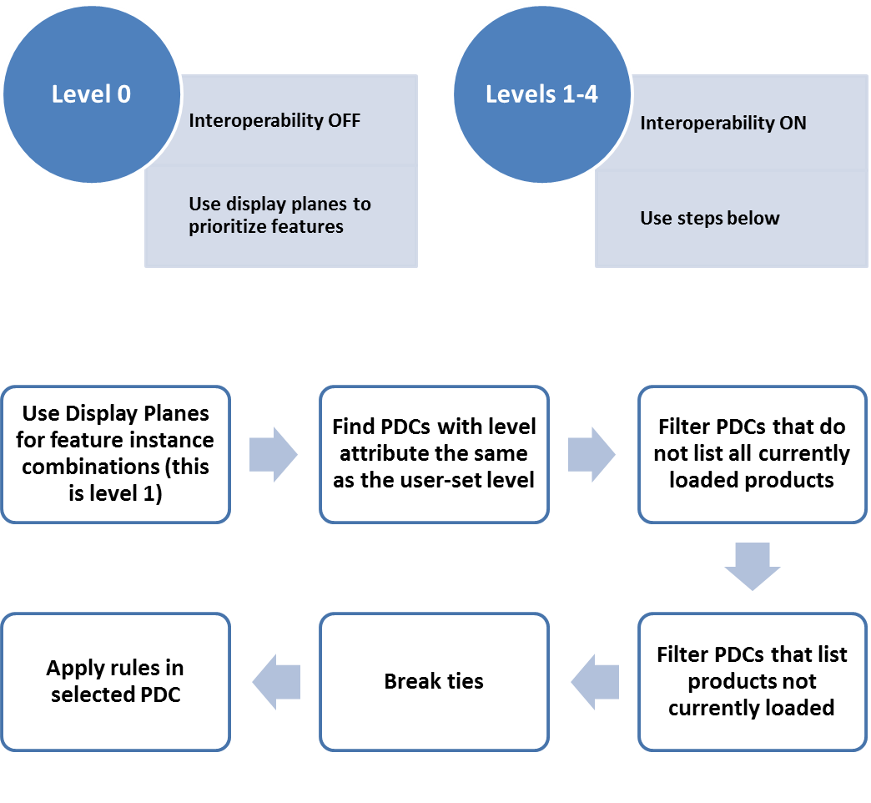

Figure 4‑1. Process for selecting rules

Product combinations are simply lists of data products. When associated to a ruleset or individual rule, it means the set or single rule applies to combinations of the data products listed. Each product combination is given attributes that identify its interoperability level and descriptive attributes that indicate its purpose and applicability to the human end-user and catalogue developer.

Display planes act as a means of layering features in the end-user’s display. Each feature in the output stream is assigned to a display plane. Each plane is assigned a display priority relative to other planes. The Interoperability Catalogue uses display planes for interleaving features from different products, with features in higher priority planes overlying those in lower priority planes wherever they overlap. In case of coincident or overlapping symbols, OEMs may use appropriate methods to avoid displaying partial symbols, or “grafting” part of lower-layer symbols onto symbols in upper layers.

The Interoperability Catalogue allows suppression of feature classes whereby the presence in one product of features of a given feature type causes the removal of all features of a specified feature type from another specified data product. This is supposed to be used when the two feature types represent the same kind of data but one data product is preferred over the other for reasons such as more detail in the preferred data product, additional feature characteristics in the preferred product, etc.

The Interoperability Catalogue also allows suppression of feature instances whereby only feature instances meeting specified conditions are suppressed in favour of feature instances from a different product. The conditions are described in terms of specific characteristics such as attribute values or combinations of values of different attributes, or the use of specific classes of spatial primitives such as all point features of the specified type.

EXAMPLE: Restricted area features from ENC datasets with category attribute = 4 (nature reserve), 5 (bird sanctuary), 7 (seal sanctuary), 23 (ecological reserve), or 31 (coral sanctuary) are suppressed in favour of restricted area features from S-122 (Marine Protected Area) datasets.

Advanced interoperability functionality will include hybridization of features. Hybridization consists of combining feature data from different products in the input stream into a new type in the output stream – new in the sense that the output feature type is not defined in any feature catalogue of the input products. Such combined types are intended for producing resultant features with enhanced characteristics, e.g., by enhancing the attribute set from one product with additional attributes derived from another data product.

### Overview of processing

Interoperability processing can either precede or follow portrayal processing (except rendering, which converts feature data into graphics and is necessarily the step just before actual display). A mixed processing model, where interoperability processing is done both before and after portrayal processing, is also possible.

* Interoperability before regular portrayal processing: Feature data from S-101 and other S-100-based datasets is an input to the interoperability processor, along with the interoperability catalogue and context parameters. The interoperability processor filters and interleaves feature data according to the Interoperability Catalogue and interoperability level selected by the user and passes the resultant feature data to the portrayal processor, which uses the portrayal catalogue for individual products to generate drawing instructions for the display processor.
* Interoperability after regular portrayal processing: Feature data from S-101 and other S-100-based datasets flows to the portrayal processor. The portrayal processor transforms them into drawing instructions. The drawing instructions flow to the interoperability processor. The interoperability processor filters and interleaves the drawing instructions according to the Interoperability Catalogue and interoperability level selected by the user and passes the resultant drawing instructions to the display processor.

Both processing options are shown in Figure 4-2 below. Details of the processing model are described in Section 14.

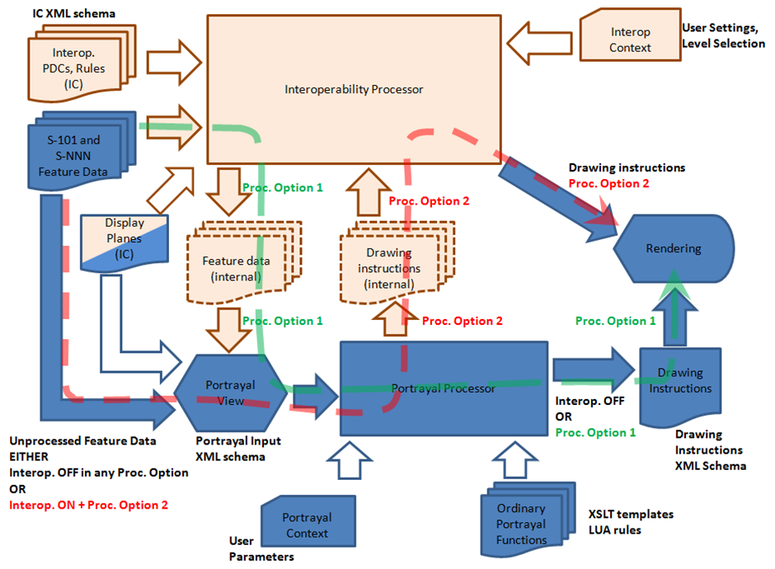

Figure 4‑2. Basic interoperability processing

*Blue: ordinary portrayal processing; beige: interoperability processing; mixed: both interoperability and ordinary portrayal. Filled block arrows: feature data; hollow block arrows: parameters or control information. The green dashed arrow shows the processing stream when interoperability precedes portrayal processing; the red dashed arrow when interoperability follows portrayal.*

## Application Schema

The interoperability Catalogue (IC) utilizes the ISO **CT_Catalogue** class defined in ISO 19139 (implemented in ISO 19115-3) as a super-type for header information. The body of the Interoperability Catalogue consists of subsections encoding the rules for display planes, feature priorities, feature interleaving, and available predefined combinations:

* display planes, indicating display priority, viewing group, and drawing order;
* predefined combinations and operations on feature types or feature instances for each combination;

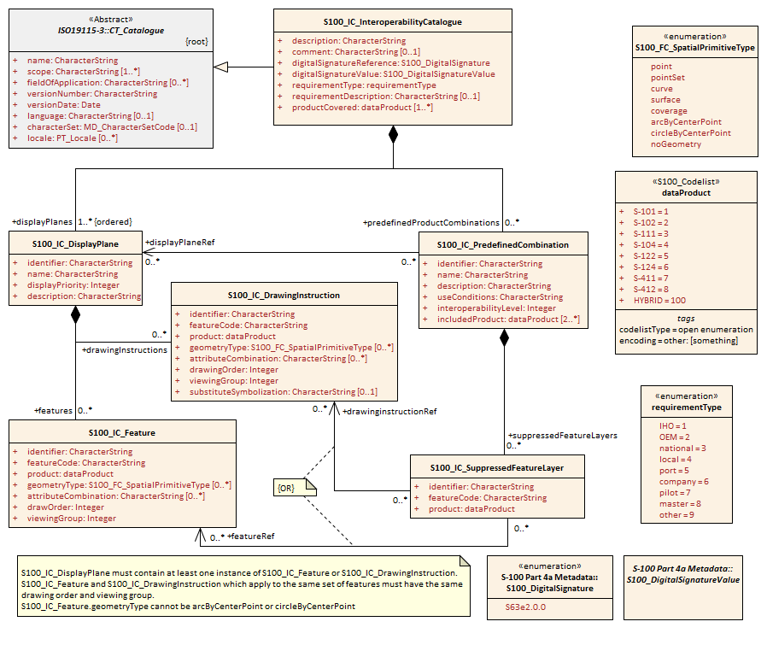

Figure 4‑3. Basic interoperability catalogue (Levels 1 & 2)

## Interoperability Catalogue

### Introduction

The Interoperability Catalogue specifies the relative display prioritization of feature types (and instances), as defined in individual product specifications, in relation to other feature types (and instances) which may be defined in any of the data products declared to be within the scope of the Interoperability Catalogue.

An Interoperability Catalogue describes display planes, predefined combinations, feature instance and feature layer suppression rules.

An Interoperability Catalogue must be an XML document which conforms to the Interoperability Catalogue Schema which can be downloaded from the IHO website.

Figure 4-3 shows the structure of a basic interoperability catalogue.

### Interoperation Conceptual Types

The following sections describe the different conceptual elements that may be used in the interoperability catalogue.

#### Display Plane (S100_IC_DisplayPlane)

A display plane element acts as a container for display information for specified feature classes (see section 4.4.2.2). The display priority for the plane as a whole is provided in the S100_IC_DisplayPlane element. All the types within an instance of S100_IC_DisplayPlane have the same display priority (encoded in attribute displayPriority) relative to feature types in another instance of S100_IC_DisplayPlane.

EXAMPLE 1: The **Marine Protected Area** feature type from S-122 is in one instance of S100_IC_DisplayPlane and the **Restricted Area Regulatory** feature type from S-101 is in a different instance with a lower priority. The display priority for all S-122 Marine Protected Area instances is higher than all S-101 **Restricted Area Regulatory** feature instances.

EXAMPLE 2: Current feature types from S-111 are in one instance of S100_IC_DisplayPlane and the **Current – non-gravitational** and **Tidal stream – flood/ebb** feature type from S-101 is in a different instance with a lower priority. The display priority for all S-111 Current feature instances is higher than all S-101 current feature instances.

Assigning feature types to display planes enables the interleaving of feature layers during portrayal by indicating the display plane, priority, and drawing order of the types assigned to a display plane.

S100_IC_DisplayPlane assigns subsets of feature types to display planes and defines the viewing group, drawing order, and significance for each feature type in the plane.

An S100_IC_DisplayPlane element may include more than one feature type.

A feature type may be referenced in more than one S100_IC_DisplayPlane, but the entries in different display planes must be distinguished by different attribute-value combinations or spatial primitives so that the actual instances of features are partitioned unambiguously between different display planes.

The portrayal of feature types not mentioned in any S100_IC_DisplayPlane component is undefined until ordinary portrayal processing.

#### Feature type display information (S100_IC_Feature)

The **S100_IC_Feature** element describes the display parameters for all features of a specific feature type in a specific product. The **S100_IC_Feature** element determines the order of drawing the feature type identified by its featureCode attribute relative to other feature types in the same display plane. It also specifies the viewing group to which the feature is assigned. Its applicability can be optionally restricted to a subset of instances of the feature type by additional attributes that specify the type of spatial primitive and indicate specific values of thematic attributes.

EXAMPLE: Subsets of the S-101 features **Restricted Area Regulatory** and **Restricted Area Navigational** are selected according to their **category of restricted area** attribute values 4 (nature reserve), 5 (bird sanctuary), 7 (seal sanctuary), 22 (fish sanctuary), or 31 (coral sanctuary).

The **S100_IC_Feature** element in interoperability catalogues is similar in operation to the layering and priority aspects of the **DrawingInstruction** element in portrayal catalogues (see S-100 Part 9 - Portrayal), and therefore has attributes that are equivalent to some of the attributes and roles of the portrayal catalogue element. Where there is an exact correspondence with a portrayal catalogue element, the element in the Interoperability Catalogue element supersedes the portrayal catalogue element. The correspondences are summarized in the table in section 4.4.2.6.

#### Feature layer (S100_IC_SuppressedFeatureLayer)

Each instance of this element identifies a feature type in a specific data product.

EXAMPLE: The S-101 features **Current – non-gravitational** and **Tidal stream – flood/ebb** are identified by S100_IC_SuppressedFeatureLayer elements as being suppressed in a predefined combination that also includes S-111 (Surface Currents) since S-111 has more detailed information about currents.

#### Predefined combination (S100_IC_PredefinedCombination)

A predefined combination element defines a collection of data products for which a common set of interoperability operations have been defined in the Interoperability Catalogue. Instances of predefined combinations are also characterized by interoperability level, which allows the encoding of different sets of operations depending on how tightly integrated the user desires the products to be on the resultant display.

The interoperabilityLevel attribute in each **S100_IC_PredefinedCombination** element specifies the highest level of interoperability operations that are encoded in the element. **S100_IC_PredefinedCombination** elements with a specified level attribute are permitted to also include operations of a lower level of interoperability.

EXAMPLE: A predefined combination has interoperabilityLevel = 2. It suppresses S-101 restricted areas of category 4 (nature reserve) in favour of S-122 Marine Protected Area features of category 4 (nature reserve) and also places S-111 current features in a lower display plane than S-101 current features. The first is Level 2 interoperability; the second is Level 1.

Predefined combinations can be linked to **S100_IC_DisplayPlane** elements by means of references in the **S100_IC_PredefinedCombination** elements.

#### Drawing instruction

Drawing instructions in the Interoperability Catalogue specify the display order used by the rendering engine in producing the portrayal output of a given feature type/geometric primitive type/attribute value combination. The **S100_IC_DrawingInstruction** element in interoperability catalogues determines the order of drawing the feature type identified by its **featureCode** attribute relative to other feature types in the same display plane. The applicability of an **S100_IC_DrawingInstruction** to feature types can be further restricted by the type of spatial primitive and values of thematic attribute, using **geometryType** and **attributeCombination** attributes of **S100_IC_DrawingInstruction**.

The **S100_IC_DrawingInstruction** element in interoperability catalogues is similar in operation to the layering and priority aspects of the **DrawingInstruction** element in portrayal catalogues (see S-100 Part 9 - Portrayal), and therefore has attributes that are equivalent to some of the attributes and roles of the portrayal catalogue element. Where there is an exact correspondence with a portrayal catalogue element, the element in the Interoperability Catalogue element supersedes the portrayal catalogue element. The correspondences are summarized in the table in section 4.4.2.6. (Definitions of individual attributes in **S100_IC_DrawingInstruction** are given in section 4.7 of this specification; definitions of the portrayal catalogue attributes are provided in S-100 Ed. 4.X/3.0.0 § 9-11.2.2).

The **S100_IC_DrawingInstruction** element contains an additional attribute that allows substitution of symbolization instructions generated by portrayal processing.

Note (informative): The display instruction XML elements defined in the presentation XML schema S-100 Part 9 (**pointInstruction**, **lineInstruction**, etc.) cannot be used directly because, being extensions of the base type **DrawingInstruction** in that schema, they: (a) reference individual feature and spatial instances, and (b) contain viewing group, display plane, and drawing priority as mandatory elements, which would be redundant.

#### Comparison and use of S100_IC_Feature and S100_IC_DrawingInstruction

**S100_IC_Feature** and **S100_IC_DrawingInstruction** elements in interoperability catalogues operate in essentially the same way as far as assignment of drawing order, priority, and display planes is concerned. They differ in that **S100_IC_DrawingInstruction** provides an optional attribute to substitute the symbolization elements of the drawing instruction.

**S100_IC_Feature** should be used for interoperability catalogues that are designed for systems where interoperability processing precedes the generation of drawing instructions.

**S100_IC_DrawingInstruction** should be used for interoperability catalogues that are designed for systems where interoperability processing precedes the generation of drawing instructions. It should also be used in all catalogues where substitution of symbolization is necessary.

##### Constraints on use of S100_IC_Feature and S100_IC_DrawingInstruction in a display plane

An instance of **S100_IC_DisplayPlane** must contain at least one instance of **S100_IC_Feature** or **S100_IC_DrawingInstruction**.

An instance of **S100_IC_DisplayPlane** may contain both **S100_IC_Feature** and **S100_IC_DrawingInstruction**, subject to the constraint below.

For **S100_IC_Feature** and **S100_IC_DrawingInstruction** with the same combination of [featureCode, product, geometryType, and attributeCombination] and in the same **S100_IC_DisplayPlane** container:

* **S100_IC_Feature.drawOrder** and **S100_IC_DrawingInstruction.drawingOrder** must have the same values.
* **S100_IC_Feature.viewingGroup** and **S100_IC_DrawingInstruction.viewingGroup** must have the same values.

##### Correspondence to and supersession of portrayal catalogue elements

Correspondences between interoperability catalogue and portrayal catalogue elements are summarized in the following table. In all cases, the supersession of portrayal catalogue display by interoperability catalogue display applies only to the subset of features remaining after applying the filter described by the attributes geometryType and attributeCombination.

Table 2. Correspondences between display instruction elements in interoperability catalogues and portrayal catalogues

|  |  |  |  |
| --- | --- | --- | --- |
| **Interoperability catalogue element** | **Portrayal catalogue element** | **Interoperability catalogue supersedes portrayal catalogue?** | **Note** |
| product | (implicit) aggregation in DisplayList | Not applicable | Implicit in aggregation in DisplayList; the product can be identified from data product to which the portrayal catalogue as a whole applies |
| drawingOrder (S100_IC_DrawingInstruction)  drawOrder (S100_IC_Feature) | drawingPriority | Y |  |
| identifier | -- | Not applicable |  |
| viewingGroup | viewingGroup | Y |  |
| geometryType | (implicit) | Y | can be derived from the implementing element in the portrayal catalogue, e.g., PointInstruction, AreaInstruction, LineInstruction. |
| attributeCombination | (XSLT template) | Y | XSLT template in portrayal catalogue |
| featureCode | (implicit in XSLT template) | Not applicable (must be compatible by definition) | Interoperability catalogue elements pertain to feature types or subsets of feature types; instances of drawing instructions in portrayal catalogues reference individual features. |
| (composition association) | displayPlane | Y | composition to S100_IC_DisplayPlane |
| -- | scaleMinimum, scaleMaximum | Not applicable |  |
| -- | featureReference association | Y | Interoperability catalogue elements do not refer to individual instances (see Example 1) |
| -- | spatialReference association | Y | Interoperability catalogue elements do not refer to individual instances (see Example 2) |
| substituteSymbolization (S100_IC_DrawingInstruction only) | (symbolization generated by portrayal processing) | Y | (See Example 3) |

EXAMPLE 1: The portrayal catalogue for an overlay product places all its features in the same display plane, but the interoperability catalogue splits them into over-radar and under-radar planes.

EXAMPLE 2: Feature **Current – non-gravitational** is allowed to have point, curve, or surface geometry. It is possible for the S-101 portrayal catalogue to place them in different viewing groups depending on the type of spatial primitive and for the interoperability catalogue to override that placement and put all instances of this feature, whether point, curve, or surface, in the same viewing group.

EXAMPLE 3: The area boundary symbolization is changed from a simple to a composite line style for area boundaries common to different types of area features, e.g., an S-101 anchorage area bordering an S-122 marine protected area.

#### Feature creation or replacement rule

Feature creation and replacement is advanced functionality whose implementation is not required for this version of the interoperability catalogue.

Feature creation and replacement rules create new feature types by combining characteristics of specified feature types from the input data products. A feature creation/replacement rule basically transforms a collection of feature instances in the input stream into one or more different feature instances in the output stream. The created feature differs from all the input features, e.g., by adding properties of one feature to properties of another feature.

Since new feature types must be defined in a feature catalogue for ECDIS use, there is also a “hybrid” feature catalogue that contains feature type specifications for all the possible feature types which can be thus generated by rules in an Interoperability Catalogue. Similarly, the hybrid portrayal catalogue describes the portrayal of these feature types.

Feature creation and replacement rules are used only in interoperability Levels 3 and 4.

The process for applying such rules is illustrated in Figure 4-4.

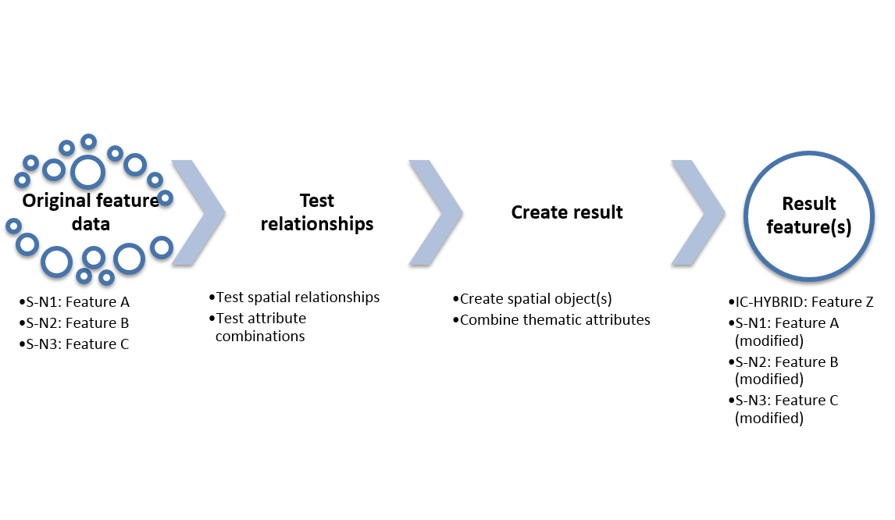

Figure 4‑4. General process for feature creation and replacement rules

A hypothetical example of the operation of such a rule is depicted in Figure 4-5. On the left are two input features:

* Feature instance DRGARE_12345 from the ENC, an instance of feature type DredgedArea defined in S-101. Its geometry is an area, depicted alongside.
* Feature instance AISMessage_8472 from the S-104 layer, an instance of feature type MetHydroDataAISMessage defined in S-104. Its geometry is a point, depicted alongside.

The operation of the rule results in two feature instances, described in Table 3 below:

Table 3. Features resulting from operation of hypothetical rule

|  |  |  |  |  |
| --- | --- | --- | --- | --- |
| **Output feature instance** | **Output feature Type** | **Defined in feature catalogue** | **Spatial attributes** | **Thematic attributes** |
| RTWL_H01 | RealTimeWaterLevelArea | Hybrid FC IHOICFC01.XML | Circle centred at location of input AISMessage_8472 | Combination of DRGARE_12345 and AISMessage_8472 |
| DRGARE_H01 | DredgedArea | S-101 FC | Spatial difference of original DRGARE_12345 and circle geometry of RTWLArea_H01 | Same as DRGARE_12345 |

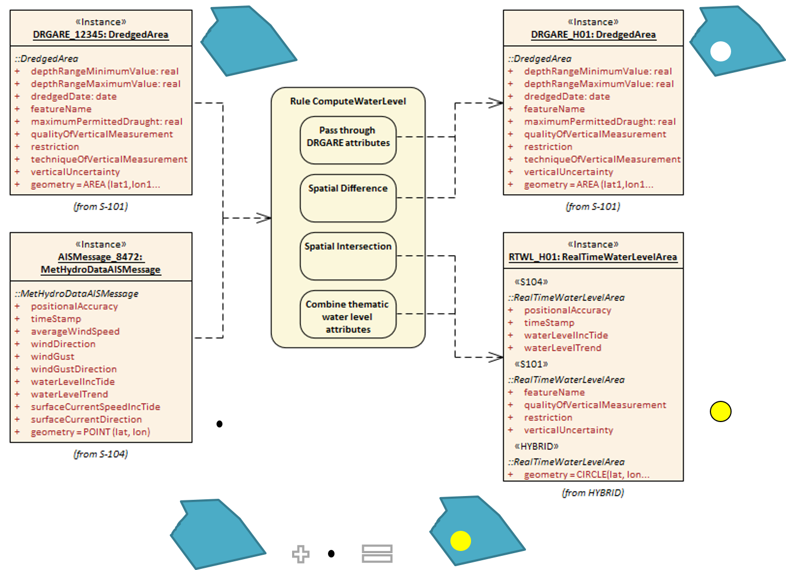

Figure 4‑5. Illustrative example of the operation of a creation/replacement rule

### Use of S-100 types

#### Geographic feature types

The relative prioritization for display purposes of S-100 geographic feature types is at the core of the Interoperability Catalogue specification. For the Interoperability Catalogue, S-100 feature types can be considered as the “domain” of the application schema, just as feature concepts form the domain of an ordinary product specification.

Feature instances are not encoded in interoperability catalogues since an Interoperability Catalogue is a catalogue-based product that is functionally a collection of rules which adjust the display of information from feature datasets; an interoperability catalogue is not itself a feature-based data product.

References to feature types may appear as attribute values in interoperability catalogues. The reference will identify the product specification in which the feature type is defined. It may also identify the version of the product specification; if the version is not identified the reference is to the indicated feature type in all versions of the product specification.

A reference to a feature type must be interpreted as applying to all instances of the feature type in datasets conforming to the indicated product specification and version. (Additional conditions limiting applicability to subsets of feature instances may be encoded in other attributes.)

#### Meta feature types

The suppression, interleaving, and replacement operations in the interoperability catalogue do not affect meta features in individual product specifications. Display of meta features if requested by the mariner is as specified by individual portrayal catalogues.

#### Feature and Information Associations

Feature and information associations are not directly used in an Interoperability Catalogue since an Interoperability Catalogue is a catalogue-like product.

Interoperability catalogues of Levels 1 and 2 do not use feature and information associations in feature filters.

Interoperability catalogues of Levels 3 and 4 may use feature and information associations in feature filters.

#### Information Types

Information types are not prioritized by an Interoperability Catalogue nor are they used directly in an Interoperability Catalogue.

#### Attributes

The Interoperability Catalogue uses the following attribute types from the S-100 GFM.

Table 4. Simple attribute types

|  |  |
| --- | --- |
| **Type** | **Definition** |
| Enumeration | A fixed list of valid identifiers of named literal values |
| Integer | A signed integer number. The representation of an integer is encapsulation and usage dependent. |
| CharacterString | An arbitrary-length sequence of characters including accents and special characters from a repertoire of one of the adopted character sets |
| Date | A date provides values for year, month and day according to the Gregorian Calendar. Character encoding of a date is a string which must follow the calendar date format (complete representation, basic format) for date specified by ISO 8601:1988.  EXAMPLE 19980918 (YYYYMMDD) |
| Time | A time is given by an hour, minute and second. Character encoding of a time is a string that follows the local time (complete representation, basic format) format defined in ISO 8601:1988.  EXAMPLE 183059  If it is required to specify time with a reference to a time zone from UTC, this is done using the following format; 183059+0100; for one hour before UTC.  If it is required to specify time according to UTC, it is done using the following format; 183059Z  The service hours for a service, that is available all year in an area where Daylight Saving Hour affects the offset to UTC could be expressed as Local Time without specified offset.  Opening: 074500  Closing: 161500 |
| Date and Time | A DateTime is a combination of a date and a time type. Character encoding of a DateTime must follow ISO 8601:1988  EXAMPLE 19850412T101530 |
| S100_CodeList | Open enumeration or identifier of entry in a vocabulary |
| S100_TruncatedDate | Truncated format for date |

Table 5. Derived types

|  |  |  |
| --- | --- | --- |
| **Derived type** | **Base type** | **Description** |
| FeatureCode | CharacterString | Restricted to the camel case code of the feature type with optional suffixes or prefixes indicating a product specification and version |
| FilterExpression | CharacterString | Restricted to the format for filter strings described in section 4.5 |
| URN | CharacterString | Restricted to the format for URN as defined by RFC 2141 |

## Filters

Attribute-value combination filters (the **attributeCombination** attribute of S100_IC_Feature) are strings of the form <attr><op><value>, where:

* 1. <attr> is the camel case code of the attribute
  2. <op> is one of “=”, “!=”, “in”, “notIn”, “gt”, “ge”, “lt”, “le”, “null”
  3. <value> is a decimal number, integer, numeric code, or string, or a list of values. Strings must be enclosed in double quotes: “” with embedded double-quotes or \ characters preceded by a \ character.

The <attr>, <op>, and <value> components are separated by blank or tab characters[1].

Sub-attributes of complex attributes can be indicated in <attr> fields using a restricted subset of relative path expressions as specified in the W3C XPath specification (§ 3.3.1 XML Path Language (XPath) 3.1). The restrictions are:

* Paths are relative to the individual feature as the context node.
* Only the “child” axis is permitted and the optional “child::” prefix is not used.
* Predicates as described in the XPath specification are not used.

The effect is to allow <attr> fields to describe sub-attributes in terms of camel case codes separated by “/*”* characters. (It also allows a simple attribute to be designated by its camel case code alone as described above.)

EXAMPLE 1: An **attributeCombination** with value *categoryOfRadioStation = 20* selects features with **categoryOfRadioStation** attributes that have the value 20 (AIS Base station).

EXAMPLE 2: An **attributeCombination** with value *featureName/language = “eng”* selects features with **featureName** attributes that have a language sub-attribute having the value “eng”.

Note (informative): Level 3 and 4 selectors may relax these restrictions and use a larger subset of XPath. Alternatively, a new language may be selected with the implementation of Levels 3 and 4.

## Interoperability Levels

The 4 interoperability levels are described in this section. Only Levels 1 and 2 are fully described in this version of the specification. Levels 3 and 4 are described for completeness but their specifications are only “informative” in this edition of the specification and they **should not be included in production implementations of this version of the interoperability catalogue**.

### Level 0 – Overlays – no explicit interoperability

In “Level 0” all interoperability processing is turned off. In this case, feature data is passed through unchanged to ordinary portrayal processing. Display plane information from the Interoperability Catalogue is also passed through since it specifies the layering which must be done by the display.

Interoperability catalogues are not used. ENC is treated as the main product on the screen, and all other products are overlays. Information layer priority continues to conform to the relevant IMO and IEC performance standards.

Data product overlays may be portrayed using transparency so as not to obscure lower layers, but transparency values are generally not adjusted using rules based on data content or feature types. They may be adjusted using context information such as the number of stacked layers or light level mode.

Level 0 interoperability is effectively equivalent to what systems do today. It is also the default fallback if a product not listed in the interoperability catalogue is loaded.

Note (informative): There is an implicit assumption here that portrayal catalogues assign features to only over/under-radar display planes. If display planes are given more complex semantics and continue to be defined in portrayal catalogues, Level 0 is likely to merge into Level 1.

### Level 1 – Interleaving

In Level 1 processing, feature types from different products, including S-101, are interleaved as specified by display plane and drawing priority information contained in the interoperability catalogue. The output of interoperability processing is either the original feature data (processing option 1) or drawing instructions (processing option 2), accompanied by display plane and drawing priority information, which is passed through to the portrayal processor.

The ENC is still treated as the main product, but feature layers from other products may be interleaved with ENC feature layers to prevent ENC data from being obscured. There is no other interoperability-related processing of feature data at this level.

### Level 2 – Type-based selectivity and feature class replacement

In Level 2 processing, Level 1 functionality is allowed as well as suppression of all features of a specified feature type in a specified product, with another feature type from a different product being displayed instead. Filtering by attribute values and geometry type is also possible. The output of interoperability processing is the same as Level 1 with certain feature types suppressed.

Feature types in other products may be determined to be superior to specific ENC feature types, in the sense that the features in the other product contain more details, have higher-resolution data values, etc., than the equivalent features in the ENC. In this level of interoperability, global suppression of equivalent ENC features in favour of the superior layer is allowed – all instances of the specified ENC feature type are suppressed and the superior feature layer is displayed.

NOTE: The criteria and process for determining what data is superior are yet to be determined.

EXAMPLE: A predefined combination suppresses S-101 Radio Calling-In Point features in favour of S-127 (Traffic Management) Radio Calling-In Point features.

Selected feature types from other products may be treated as being superior to or enhancing selected ENC feature instances. The features are selected using filters (encoded in field **attributeValueCombination**) that use feature type and values of thematic attributes. The geometry of the superior feature instance must be spatially equal to that of the ENC feature instance (within specified tolerances).

The interoperability result is that the selected ENC feature instances are suppressed or replaced by the specified features from the other product. Only thematic attributes can be used in **attributeValueCombination** fields.

Selection of replaced and replacement features in this level uses feature type (and data product) information. The only operation is replacement of instances as a whole, no combination of replaced and replacement information is done.

Level 2 catalogues may also include Level 1 functionality for some features where appropriate.

EXAMPLE: A predefined combination suppresses S-101 restricted areas of category 4 (nature reserve) in favour of S-122 Marine Protected Area features.

### Level 3 – Feature hybridization

As in Level 2, the ENC is treated as one of the components of the data stack, and selected feature instances from other products may be treated as being superior to or enhancing selected ENC feature instances. The feature instances are selected using selector expressions that use feature type and values of thematic attributes. The geometry of the superior/enhancing feature instance must be spatially equal to that of the ENC feature instance (within specified tolerances).

Level 3 extends interoperability functionality of Level 2 in that the ENC feature instance is either suppressed or replaced by the other feature instance (as in Level 2) or hybridized with it - i.e., their attributes are combined in some way. In Level 3, only thematic attributes can be combined for the purposes of hybridization.

Hybridization may consist of adjustments to attributes of one of the ENC/other feature instances, such as re-calculation of values of numeric attribute, addition of listed values to an enumeration attribute. Hybridization may also result in an instance of a different feature type with an enhanced set of thematic attributes, some of which may be new attributes generated from attribute values of the original instances.

The interoperability product will include a hybrid feature catalogue and portrayal catalogue defining the feature types and portrayals for new hybrid features. Their structures will be the same as regular feature and portrayal catalogues.

Support for this level is not fully elaborated in this version of the Interoperability Catalogue Specification and it should therefore not be implemented in interoperability catalogues created from this specification

### Level 4 – Spatial operations

This level is the same as Level 3, but permitted spatial queries (to determine related subsets) and operations (to define the interoperation result) are explicitly defined using an adequate set of spatially-capable rules.

This means that the ENC and other-product feature(s) need not be spatially equal, they need only be related to one another by the spatial query. For hybridization, in addition to thematic attributes, feature geometry can also be combined using spatial operations.

Note: The spatial queries for determining related ENC/other-product features can be defined in terms of explicit rules such as positions within X m, or X mm at product scale for point features, 99% overlap for area features, or some other adequate explicit rule.

Support for this level is not fully elaborated in this version of the Interoperability Catalogue Specification and it should therefore not be implemented in interoperability catalogues created from this specification

### Progression of interoperability levels

Higher levels of interoperability use progressively more of the interoperability catalogue model. Figure 4-6 shows the additional components of the model used in Level 2 compared to Level 1. Level 2 may use **S100_IC_PredefinedCombination** and **S100_IC_SuppressedFeatureLayer** elements in addition to **S100_IC_DisplayPlane**, **S100_IC_Feature**, and **S100_IC_DrawingInstruction**.

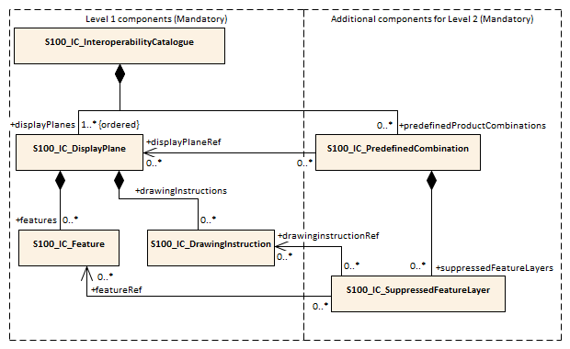

Figure 4‑6. Progressive use of interoperability catalogue model - Levels 1 and 2 compared

## UML model documentation tables

The tables in this section describe an Interoperability Catalogue that is capable of Interoperability Levels 1 and 2 as depicted in Figure 4-3.

Table 6. S100_IC_DisplayPlane

|  |  |  |  |  |  |
| --- | --- | --- | --- | --- | --- |
| **Role Name** | **Name** | **Description** | **Mult** | **Type** | **Remarks** |
| Class | S100_IC_DisplayPlane | Each display plane identifies all features and their draw orders within the plane. Display priority defines the order in which display planes are rendered. | -- | -- | Composition component of S100_IC_InteroperabilityCatalogue, container displayPlanes |
| Attribute | identifier | unique identifier of the display plane | 1 | CharacterString | must be unique |
| Attribute | name | Name of display plane | 1 | CharacterString | under radar, over radar, etc. |
| Attribute | displayPriority | display priority controls the order in which the output of the portrayal functions is processed by the rendering engine. Priorities with smaller numerical values will be processed first. | 1 | Integer | Ref. S-100 § 9-12.1 |
| Attribute | description | description of the display plane | 1 | CharacterString |  |
| Composition | features | Container for S100_IC_Feature elements | (container)  0..* | <sequence>S100_IC_Feature | At least one S100_IC_Feature or S100_IC_DrawingInstruction element must be included in a display plane element |
| Composition | drawingInstructions | Container for S100_IC_DrawingInstruction elements | (container)0..* | <sequence>S100_IC_DrawingInstruction | At least one S100_IC_Feature or S100_IC_DrawingInstruction element must be included in a display plane element |

Table 7. S100_IC_DrawingInstruction

|  |  |  |  |  |  |
| --- | --- | --- | --- | --- | --- |
| **Role Name** | **Name** | **Description** | **Mult** | **Type** | **Remarks** |
| Class | S100_IC_DrawingInstruction | Information that guides the relative layering and drawing order of drawing instruction during portrayal. | -- | -- |  |
| Attribute | product | A data product | 1 | dataProduct |  |
| Attribute | drawingOrder | The drawing order of the group | 1 | Integer |  |
| Attribute | identifier | Internal identifier of the instruction group. | 1 | CharacterString | This may map to viewing groups, but it is just an identifier for now to keep things simple. |
| Attribute | viewingGroup | The viewing group of the feature type | 1 | Integer | Ref. S-100 § 9-12.1 |
| Attribute | geometryType | The type of spatial primitive that indicates the location. | 0..* | S100_FC_SpatialPrimitiveType |  |
| Attribute | attributeCombination | Describes attribute-value filters to be applied to the specified features | 0..* | CharacterString | See Section 4.5 |
| Attribute | featureCode | the code assigned to the feature type in feature catalogue for the product indicated in the product attribute | 1 | CharacterString | Corresponds to the feature reference for drawing instructions in S-100 Part 9. |
| Attribute | substituteSymbolization | Substitute for the symbolization content of drawing instructions. This can be any element of the drawing instruction not defined in the abstract class DrawingInstruction defined in S-100 3.0.0/4.X Part 9 clause 9-11.2, but defined in the relevant descendant of that class. | 0..1 | CharacterString | The string must consist of one or more XML fragments constructed according to the Presentation schema in S-100 Part 9 or the equivalent in a non-XML syntax. A CDATA section may be used to avoid the explicit encoding of character entities for special characters. |

Note for implementers: Even if the Presentation schema in S-100 Part 9 is used, implementers may need to provide specific code to validate the content of the substituteSymbolization attribute instead of depending on normal XML schema validation. The content of this attribute is not prescribed by this specification and may be a fragment of XML, or interpretable code or rules, etc., in a non-XML syntax. It may be enclosed in a <![CDATA[ … ]]> section so that XML validators treat it as character data instead of XML.

Table 8. S100_IC_Feature

|  |  |  |  |  |  |
| --- | --- | --- | --- | --- | --- |
| **Role Name** | **Name** | **Description** | **Mult** | **Type** | **Remarks** |
| Class | S100_IC_Feature | Information that guides the relative layering and drawing order of feature types during portrayal. | -- | -- |  |
| Attribute | identifier | Internal identifier of the catalogue element. | 1 | CharacterString |  |
| Attribute | featureCode | the code assigned to the feature type in feature catalogue for the product indicated in the product attribute | 1 | CharacterString |  |
| Attribute | product | A data product | 1 | Enumeration dataProduct |  |
| Attribute | drawOrder | Drawing order of feature type in the display plane | 1 | Integer |  |
| Attribute | viewingGroup | The viewing group of the feature type | 1 | Integer | Ref. S-100 § 9-12.1 |
| Attribute | geometryType | The type of spatial primitive that indicates the location. | 0..* | S100_FC_SpatialPrimitiveType |  |
| Attribute | attributeCombination | Describes attribute-value filters to be applied to the specified features | 0..* | CharacterString | See Section 4.5 |

Table 9. S100_IC_InteroperabilityCatalogue

|  |  |  |  |  |  |
| --- | --- | --- | --- | --- | --- |
| **Role Name** | **Name** | **Description** | **Mult** | **Type** | **Remarks** |
| Class | S100_IC_InteroperabilityCatalogue | An interoperability catalogue contains operations and rules for the interoperation of a set of S-100-based data products. | -- | -- | Specialization of CT_Catalogue (ISO 19115-3) |
| Attribute | description | Description of the catalogue | 1 | CharacterString |  |
| Attribute | comment | Any additional comments | 0..1 | CharacterString |  |
| Attribute | digitalSignatureReference | Reference for digital signature algorithm | 1 | S100_DigitalSignature | Reference to the appropriate digital signature algorithm |
| Attribute | digitalSignatureValue | Digital Signature of the file | 1 | *S100_DigitalSignatureValue* (Abstract type) | The value resulting from application of digitalSignatureReference. |
| Attribute | requirementType | The type of authority or requestor responsible for the specifications, rules, or requirements based on which this catalogue was prepared. | 1 | Enumeration |  |
| Attribute | requirementDescription | Description of the source of the requirements or specifications upon which this catalogue is based. This might be the name of the country, company, OEM, port, pilot, etc. | 1 | CharacterString |  |
| Attribute | productCovered | The products covered by this catalogue | 1..* | Enumeration |  |
| Attribute | name | The name for the catalogue | 1 | CharacterString | Inherited from CT_Catalogue |
| Attribute | scope | Subject domain of the catalogue | 1..* | CharacterString | Inherited from CT_Catalogue |
| Attribute | fieldOfApplication | Description of the use to which this catalogue may be put | 0..* | CharacterString | Inherited from CT_Catalogue |
| Attribute | versionNumber | The version number of the product specification | 1 | CharacterString | Inherited from CT_Catalogue |
| Attribute | versionDate | The version date of the product specification | 1 |  | Inherited from CT_Catalogue |
| Attribute | language | The language used for this catalogue | 0..1 | CharacterString | Inherited from CT_Catalogue |
| Attribute | locale | provides information about alternatively used localised character strings | 0..1 | PT_Locale (ISO 19115-1) | Inherited from CT_Catalogue |
| Attribute | characterSet | Character set used in the catalogue | 0..1 | MD_CharacterSetCode (ISO 19115-1) | Inherited from CT_Catalogue  value=utf8 |
| Composition | displayPlanes | Container for one or more S100_IC_DisplayPlane elements | 1..* | <sequence>S100_IC_DisplayPlane | ordered list of one or more S100_IC_DisplayPlane elements |
| Composition | predefinedProductCombinations | Container for predefined product combinations and the interoperability operations for each | 0..* | <sequence>S100_IC_PredefinedCombination | sequence of S100_IC_PredefinedCombination elements |

Table 10. S100_DigitalSignature

|  |  |  |  |  |  |
| --- | --- | --- | --- | --- | --- |
| **Role Name** | **Name** | **Description** | **Code** | **Type** | **Remarks** |
| Enumeration | S100_DigitalSignature | Algorithm used to compute the digital signature | - | - | - |
| Value | S63e2.0.0 | S-63 digital signature algorithm specified by IHO | - | - | See S-100 Part 15. |

Table 11. S100_DigitalSignatureValue

|  |  |  |  |  |  |
| --- | --- | --- | --- | --- | --- |
| **Role Name** | **Name** | **Description** | **Mult** | **Type** | **Remarks** |
| Class | S100_DigitalSignatureValue | Abstract class representing the digital signature value | - | Abstract class | This class is implemented by a type that conforms to one of the signature formats specified in S-100 Part 15. Since the structure is at present unstable and may depend on the algorithm, it is represented here as an abstract type. |

Table 12. S100_IC_PredefinedCombination

|  |  |  |  |  |  |
| --- | --- | --- | --- | --- | --- |
| **Role Name** | **Name** | **Description** | **Mult** | **Type** | **Remarks** |
| Class | S100_IC_PredefinedCombination | Pre-defined combinations are identifiable pre-set collections of recommended and optional S-NNN data products which are expected to be loaded by the user under specific conditions or for specified tasks. Each pre-defined combination is basically a package of data products, display priorities, context parameters, user settings, portrayal catalogues, etc. An ECDIS or other system can allow the user to initiate the loading of multiple data products and activate multiple parameter settings as a single action, by selecting one of a list of pre-defined combinations, instead of loading and unloading individual data products. | -- | -- | Composition component of S100_IC_InteroperabilityCatalogue |
| Attribute | identifier | Identifier of the predefined combination | 1 | CharacterString | E.g., sequence number, UUID or URN unique to the PDC in the catalogue. May be globally unique, but must be unique within the catalogue at least |
| Attribute | name | Name of combination | 1 | CharacterString |  |
| Attribute | description | Brief description of combination | 1 | CharacterString |  |
| Attribute | useConditions | Conditions for which the combination is designed | 1 | CharacterString |  |
| Attribute | interoperabilityLevel | The highest level of interoperability functionality encoded within an instance of this type | 1 | Integer |  |
| Attribute | includedProduct | Products loaded in this combination and referenced by operations and rules that apply to this combination. | 2..* | Enumeration dataProduct | A combination must use at least 2 data products |
| Role | displayPlaneRef | Reference to an S100_IC_DisplayPlane element in this interoperability catalogue | 0..* | <reference>S100_IC_DisplayPlane |  |

Table 13. S100_IC_SuppressedFeatureLayer

|  |  |  |  |  |  |
| --- | --- | --- | --- | --- | --- |
| **Role Name** | **Name** | **Description** | **Mult** | **Type** | **Remarks** |
| Class | S100_IC_SuppressedFeatureLayer | Describes operations for suppressing all instances of a feature type in one product by features from another product. | -- | -- |  |
| Attribute | identifier | Internal identifier of the catalogue element. | 1 | CharacterString |  |
| Attribute | featureCode | feature type code in the FC for the product mentioned in attribute **product** | 1 | CharacterString |  |
| Attribute | product | the data product for the type being replaced | 1 | Enumeration dataProduct |  |
| Role | featureRef | references to replacement features’ display specifications in the display planes section of the interoperability catalogue | 0..* | <reference>S100_IC_Feature | Replacement by multiple feature types is intended for associated feature types, e.g., different feature types for a traffic separation scheme.  If both feature and drawing instruction references are empty, the type is suppressed without being replaced. |
| Role | drawingInstructionRef | reference to S100_DrawingInstruction element | 0..* | <reference>S100_IC_DrawingInstruction | If both feature and drawing instruction references are empty, the type is suppressed without being replaced. |

Table 14. dataProduct

|  |  |  |  |  |
| --- | --- | --- | --- | --- |
| **Role Name** | **Name** | **Description** | **Code** | **Remarks** |
| S100_Codelist | dataProduct | List of data products | -- | Data products conforming to the specification identified by the item name, in the IHO list of S-100 based product specifications |
| Literal | S-101 | ENC data product | 1 |  |
| Literal | S-102 | Bathymetry data product | 2 |  |
| Literal | S-111 | Surface Current data product | 3 |  |
| Literal | S-104 | Water Level for Surface Navigation data product | 4 |  |
| Literal | S-122 | Marine Protected Areas data product | 5 |  |
| Literal | S-124 | Navigational Warnings data product | 6 |  |
| Literal | S-411 | Sea ice Information data product | 7 |  |
| Literal | S-412 | Weather overlay data product | 8 |  |
| Literal | HYBRID | Hybrid features created during interoperability processing | 100 | Defined for interoperability processing, not in the IHO list. |

Codelist Type: open enumeration

Encoding for extra values: other: <CharacterString> (Format of <CharacterString>: **[a-zA-Z0-9]+( [a-zA-Z0-9]+)\*** - See S-100 3-6.7.) Further restricted in this specification to be an S-100-based product specification from the list maintained by IHO in the GI registry. Note that punctuation characters such as hyphens are not allowed by the S-100 pattern for the extra values.

Combining these constraints means the extra values must be of the form: **other: [A-Z][0-9]+** that is, an upper-case letter followed by a sequence of digits. For example: **other: S127**

Table 15. requirementType

|  |  |  |  |  |
| --- | --- | --- | --- | --- |
| **Role Name** | **Name** | **Description** | **Code** | **Remarks** |
| Enumeration | requirementType | The source of the catalogue or the person or party according to whose recommendations the catalogue was prepared. | -- |  |
| Literal | IHO | Original IHO interoperability catalogue | 1 |  |
| Literal | OEM | Prepared according to requirements specified by OEM or systems integrator | 2 |  |
| Literal | national | Prepared according to requirements specified by a national government, group of national governments (e.g., the European Union), or governmental agency such as a national shipping authority or the Coast Guard. | 3 |  |
| Literal | local | Prepared according to requirements specified by a sub-national governmental authority such as a state, province, or county. | 4 |  |
| Literal | port | Prepared according to requirements specified by a harbormaster's office or port authority | 5 |  |
| Literal | company | Prepared according to requirements specified by the owner, charterer, or operator | 6 |  |
| Literal | pilot | Prepared according to requirements specified by the vessel’s master | 7 |  |
| Literal | master | Prepared according to requirements specified by a pilot | 8 |  |
| Literal | other | Other source | 9 |  |

## Application schema for higher-level catalogues (informative)

This section describes interoperability functionality that extends the basic functionality of Levels 1 and 2. **Implementation of the constructs in this section is not required for implementations of this version of the interoperability catalogue.**

The application schema for the entire catalogue, including Level 3 and 4 constructs, is depicted in Figure 4‑7. It consists of the components depicted in Figure 4-3 and the following additional components:

* operations on feature instances for a predefined combination;
* rules for combining feature data into new features, used by certain operations in the predefined combination section;
* feature and portrayal catalogues for the new features generated according to the combination rules.

### Shared components

Header information, display planes, and predefined combinations are the same as in the Basic Interoperability Catalogue.

### Enhancements of shared components

#### Operations in PDCs

In addition to the operations specified for the Basic Interoperability Catalogue, a PDC can specify the following types of interaction between its listed products.

1. Operations on selected instances of a feature type or conversion of input feature data into new feature data involving only thematic attributes (Level 3 interoperability).
2. Operations involving operations on spatial attributes (and possibly thematic attributes as well). This is Level 4 interoperability.

The simplest operations on instances are replacement of selected instances from one product by selected instances from another product. These are described by S100_IC_SuppressedFeatureInstance elements. More complex operations, including conversion of input feature instances into new features(hybridization) are described by S100_IC_HybridFeature elements. The replacement and hybridization rules are described in Section 8.4.

#### Enhanced selection of feature instances

S100_IC_SuppressedFeatureInstance and S100_IC_HybridFeature elements specify the feature types on which they operate by indicating the product and feature types of two products. Selection of feature instances is done by evaluating a filter expression (type FeatureSelector, a string expression conforming to the specified [TBD] format) with the feature instance as input parameter. A FeatureSelector is a more expressive form of the attributeCombination filter described in section 4.5 that can include spatial operations and more complex expressions on thematic attributes.

[Note: If a scripting language for selection is developed it will belong in this level – the TBD in the previous sentence would be the specification of the scripting language, and equally importantly, their call/function signatures and restrictions on what the scripts are allowed to do.]

For Level 3 interoperability, spatial equality is an implied criterion in determining each input instance set of feature instances to be converted to new feature data uses spatial equality as an implicit criterion for set membership, i.e., only coincident instances (to a system-determined tolerance) are combined, and the geometry of the output is the same as the geometry of any instance in the input set.

For Level 4 interoperability, complex spatial operations are permitted but there is an implicit assumption that the members of the input instance set are meaningfully related spatially (e.g., 95% common area). In Level 4 interoperability, the spatial attributes of the output instance may be generated by applying spatial operators (e.g., spatial union, intersection, etc.) to the spatial attributes of the input instance set. The allowed spatial operations are the methods for testing spatial relations described in S-58 Edition 6.0.0 § 2 extended with [TBD].

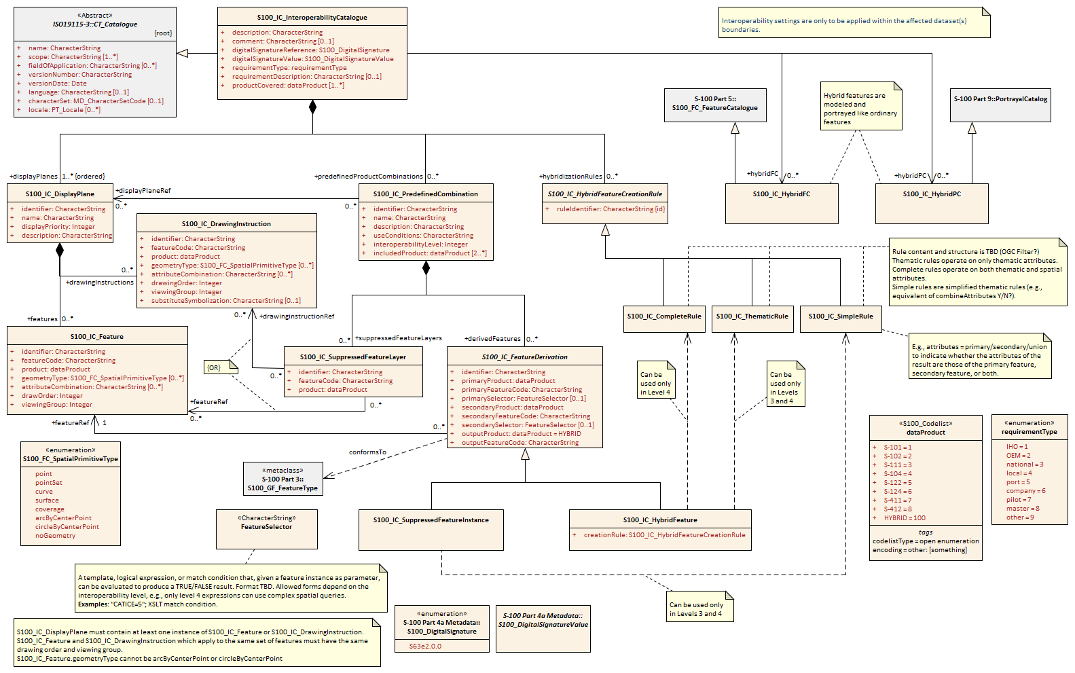

Figure 4‑7. Application schema for full interoperability catalogue

### Interoperability levels

As in the Basic Interoperability Catalogue, the interoperabilityLevel attribute in each S100_IC_PredefinedCombination element specifies the highest level of interoperability operations that are encoded in the element. S100_IC_PredefinedCombination elements are permitted to also include operations of a lower level of interoperability.

### Hybridization rules

Hybridization rules define how a set of feature instances is combined to create a hybrid feature type. In the simplest form of hybridization, the hybrid feature would bind all the attributes of the input types to a single output feature type. (This assumes that there are no collisions between the thematic attributes of the input types.) More complex hybridization rules can handle collisions, e.g. by defining a preference order for colliding attributes, including all the values if the input types bind the same enumerated attribute, or adding uncertainty metadata if numeric attribute values are different.

The hybridization rules require two feature instances as input and produce a single feature instance as output. The formal specification and rule language for hybridization will be described in a subsequent version of this specification.

#### Simple hybridization rule

Simple rules treat thematic attributes uniformly, for example by binding the attributes of both primary and secondary input instances to the output instance, or preferring the attribute bindings of the primary instance to those of the secondary instance in case of a difference in the values of common attributes. Location/extent spatial attributes of all input instances must be spatially equal and are passed through unchanged.

#### Thematic hybridization rule

Thematic rules treat thematic attributes on an individual basis, for example, use specified attributes from the primary input instance and specified attributes from the secondary input instance. Combination operations on attribute values may be specified (e.g., OutputFeature.depthValue = maximum(ProductA.FeatureX.depthValue , ProductB.FeatureY.depthValue) Location/extent spatial attributes of all input instances must be spatially equal and are passed through unchanged.

#### Complete hybridization rule

Complete rules allow selection of input sets using complex spatial queries as well as spatial equality and selector expressions on attribute values. The output can combine thematic attributes in any of the ways allowed by thematic hybridization rules. In addition, it may generate complex spatial objects from the input spatial primitives by applying selected spatial operations to the input instances. The allowed spatial operations will be identified in a future edition of this specification (tentatively, the spatial operations defined in S-58 6.0.0).

### Hybrid feature and portrayal catalogues

Hybrid feature and portrayal catalogues are physically separate files from the main interoperability catalogue, but the main catalogue links to them by encoding the names of the hybrid catalogue files which are used by the feature creation rules defined in it. The hybrid feature and portrayal catalogues conform to the structures required by S-100 Parts 5 and 9 respectively.

### Progression of interoperability levels for advanced interoperability

Figure 4-8 shows the additional components of the model used in Levels 3 and 4 compared to Levels 1 and 2. Level 3 adds elements related to thematic hybridization while Level 4 adds rules that can use spatial operations. As always, predefined combinations at any level can also use lower-level functionality

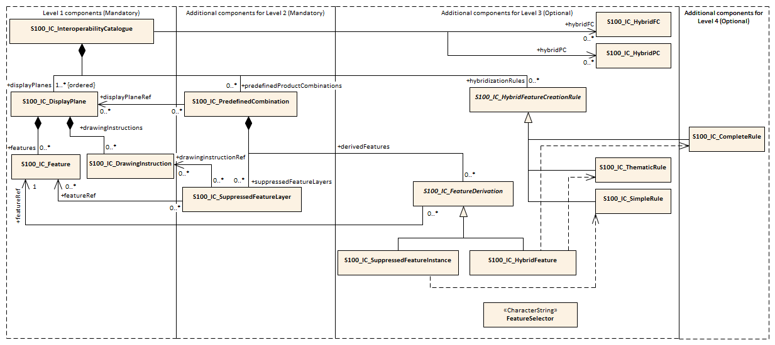

Figure 4‑8. Progressive use of interoperability catalogue model from Level 1 to Level 4

## Additional documentation tables for advanced interoperability catalogues (informative)

The following additions are made to the classes, attributes, and datatypes specified for the Basic Interoperability Catalogue.

Table 16. S100_IC_CompleteRule

|  |  |  |  |  |  |
| --- | --- | --- | --- | --- | --- |
| **Role Name** | **Name** | **Description** | **Mult** | **Type** | **Remarks** |
| Class | S100_IC_CompleteRule | Rule describing how a set of feature instances is combined to create a hybrid feature type.Complete rules may operate on both thematic and spatial attributes. | -- | -- | Subclass of S100_IC_HybridFeatureCreationRule |
| Attribute | ruleIdentifier | Rule identifier | 1 | CharacterString | Inherited from S100_IC_HybridFeatureCreationRule  Mandatory unique ID used for references. |

Table 17. S100_IC_FeatureDerivation

|  |  |  |  |  |  |
| --- | --- | --- | --- | --- | --- |
| **Role Name** | **Name** | **Description** | **Mult** | **Type** | **Remarks** |
| Class | S100_IC_FeatureDerivation | Derived features are created by consolidating features from 2 or more different products into one final view, so the changes can include geometry, attribution and/or portrayal (depending on the interoperability level). | -- | -- | Abstract class.  Individual primary and secondary inputs are suppressed from being rendered and only the resulting derived feature is added to the data stack.  The resulting derived feature does not need to have any hybrid characteristics i.e. one restricted area replaced with another restricted area will use regular PC/FC of the primary product. However if the result feature needs to be supported by any custom FC or PC elements they must be defined under hybrid FC and hybrid PC accordingly.  A rule for creating the feature must be described in the rules section. |
| Attribute | identifier | Internal identifier of the catalogue element. | 1 | CharacterString |  |
| Attribute | primaryProduct | one of the two interoperating data products | 1 | Enumeration dataProduct |  |
| Attribute | primaryFeatureCode | feature type code in the FC for the product mentioned in primaryProduct | 1 | CharacterString |  |
| Attribute | primarySelector | Selection expression for instances of the first feature type. | 0..1 | FeatureSelector | If omitted, all instances of the type are included.  In L3 processing, may contain only thematic attributes and the primary and secondary instance geometries must be spatially equal.  L3 Example: CATICE=5  In L4 processing, expressions may also contain spatial attributes.  L4 Example: CATICE=5 AND WITHIN(<primary>, <secondary>) |
| Attribute | secondaryProduct | the other interoperating data product | 1 | Enumeration dataProduct |  |
| Attribute | secondaryFeatureCode | feature type code in the FC for the product mentioned in secondaryProduct | 1 | CharacterString |  |
| Attribute | secondarySelector | Selection expression for instances of the second feature type. | 0..1 | FeatureSelector | If omitted, all instances of the type are included.  In L3 processing, may contain only thematic attributes and the primary and secondary instance geometries must be spatially equal.  L3 Example: CATICE=5  In L4 processing, expressions may also contain spatial attributes.  L4 Example: CATICE=5 AND WITHIN(<secondary>, <primary>) |
| Attribute | outputProduct | data product of the resulting hybrid feature | 1 | Enumeration dataProduct | default value = HYBRID, to indicate the result is a hybrid feature. |
| Attribute | outputFeatureCode | feature type code in the hybrid FC | 1 | CharacterString |  |
| Role | featureRef | reference to the output feature’s display specification in the display planes section of the interoperability catalogue | 1 | <reference>S100_IC_Feature |  |

Notes: S100_IC_FeatureDerivation is an abstract super-class for different types of feature hybridization operations.

Table 18. S100_IC_HybridFC

|  |  |  |  |  |  |
| --- | --- | --- | --- | --- | --- |
| **Role Name** | **Name** | **Description** | **Mult** | **Type** | **Remarks** |
| Class | S100_IC_HybridFC | Feature catalogue defining any "hybrid feature types" that are created by combining feature types from two or more products for the purposes of an interoperable display. | -- | S100_FC_FeatureCatalogue | The Interoperability Catalogue contains references to local resources (files) containing hybrid FCs. |
| Attributes and Roles | (See S-100 Part 5) |  |  |  |  |

Table 19. S100_IC_HybridFeature

|  |  |  |  |  |  |
| --- | --- | --- | --- | --- | --- |
| **Role Name** | **Name** | **Description** | **Mult** | **Type** | **Remarks** |
| Class | S100_IC_HybridFeature | Feature created by combining feature types from two or more products for the purposes of an interoperable display. | -- | S100_IC_FeatureDerivation | Sub-class of S100_IC_FeatureDerivation |
| Attribute | creationRule | Reference to a rule defined in the hybridization rules section of the catalogue | 1 | <reference>S100_IC_HybridfeatureCreationRule |  |
| Attributes | primaryProduct  primaryFeatureCode  primarySelector  secondaryProduct  secondaryFeatureCode  secondarySelector  outputProduct  outputFeatureCode | (See S100_IC_FeatureDerivation) |  | -- | Inherited from S100_IC_FeatureDerivation |
| Role | featureRef | (See S100_IC_FeatureDerivation) | 1 | <reference>S100_IC_Feature | Inherited from S100_IC_FeatureDerivation |

Table 20. S100_IC_HybridFeatureCreationRule

|  |  |  |  |  |  |
| --- | --- | --- | --- | --- | --- |
| **Role Name** | **Name** | **Description** | **Mult** | **Type** | **Remarks** |
| Class | S100_IC_HybridFeatureCreationRule | Hybrid feature creation rule captures the entire data filtering logic (i.e. finding all features to be operated on) as well as the entire processing logic. | -- | -- | Abstract class. |
| Attribute | ruleIdentifier | Rule identifier | 1 | CharacterString | Mandatory unique ID used for references. |

Notes: S100_IC_HybridFeatureCreationRule is an abstract super-class for different types of hybridization rules. This functionality needs to be worked out but OGC Filter seems to be the ideal option for defining data filtering logic.

Overall, the output from execution of S100_IC_HybridFeatureCreationRule is a set of hybrid features for which predefined FC, PC and display plane definitions already exist so such feature will be suitable for passing to the portrayal engine for processing just like any other S100 features.

Table 21. S100_HybridPC

|  |  |  |  |  |  |
| --- | --- | --- | --- | --- | --- |
| **Role Name** | **Name** | **Description** | **Mult** | **Type** | **Remarks** |
| Class | S100_IC_HybridPC | Portrayal catalogue defining portrayal rules for the "hybrid feature types" defined in a Hybrid Features Catalogue. | -- | (S-100 Part 9) PortrayalCatalog | The Interoperability Catalogue contains references to local resources (files or folders) defining hybrid PCs. |
| Attributes and Roles | (See S-100 Part 9) |  |  |  |  |

Table 22. S100_IC_InteroperabilityCatalogue

The following roles are added to the specification for Phase 1.

|  |  |  |  |  |  |
| --- | --- | --- | --- | --- | --- |
| **Role Name** | **Name** | **Description** | **Mult** | **Type** | **Remarks** |
| Class | S100_IC_InteroperabilityCatalogue | An interoperability catalogue contains operations and rules for the interoperation of a set of S-100-based data products. | -- | -- | Specialization of CT_Catalogue (ISO 19115-3) |
| Role | hybridFC | Reference to hybrid feature catalogue used by operations in this interoperability catalogue | 0..* | CharacterString | URI referencing a local file containing the hybrid FC. |
| Role | hybridPC | Reference to hybrid portrayal catalogue used by operations in this interoperability catalogue | 0..* | CharacterString | URI referencing the local file containing the main file for the hybrid portrayal catalogue. |
| Composition | hybridizationRules | Container for hybridization rules | 0..* | <sequence>S100_IC_HybridizationRule | sequence of non-abstract specializations of S100_IC_HybridizationRule |

Table 23. S100_IC_PredefinedCombination

The following composition is added to the specification for Phase 1.

|  |  |  |  |  |  |
| --- | --- | --- | --- | --- | --- |
| **Role Name** | **Name** | **Description** | **Mult** | **Type** | **Remarks** |
| Class | S100_IC_PredefinedCombination | Pre-defined combinations are identifiable pre-set collections of recommended and optional S-NNN data products which are expected to be loaded by the user under specific conditions or for specified tasks. Each pre-defined combination is basically a package of data products, display priorities, context parameters, user settings, portrayal catalogues, etc. An ECDIS or other system can allow the user to initiate the loading of multiple data products and activate multiple parameter settings as a single action, by selecting one of a list of pre-defined combinations, instead of loading and unloading individual data products. | - | - | Composition component of S100_IC_InteroperabilityCatalogue |
| Composition | derivedFeatures | Container for S100_SuppressedFeatureInstance or S100_IC_HybridFeature elements (concrete specializations of S100_IC_DerivedFeature) | 0..* | <sequence> of sub-classes of S100_IC_DerivedFeature | sequence of S100_SuppressedFeatureInstance or S100_IC_HybridFeature elements |

Table 24. S100_IC_SimpleRule

|  |  |  |  |  |  |
| --- | --- | --- | --- | --- | --- |
| **Role Name** | **Name** | **Description** | **Mult** | **Type** | **Remarks** |
| Class | S100_IC_SimpleRule | Rule describing how a set of feature instances is combined to create a hybrid feature type. Simple rules may operate only on thematic attributes. Simple rules treat thematic attributes uniformly during hybridization and therefore do not mention specific attributes. Location/extent spatial attributes of all input features must be spatially equal. | -- | -- | Subclass of S100_IC_HybridFeatureCreationRule |
| Attribute | ruleIdentifier | Rule identifier | 1 | CharacterString | Inherited from S100_IC_HybridFeatureCreationRule  Mandatory unique ID used for references. |

Table 25. S100_IC_SuppressedFeatureInstance

|  |  |  |  |  |  |
| --- | --- | --- | --- | --- | --- |
| **Role Name** | **Name** | **Description** | **Mult** | **Type** | **Remarks** |
| Class | S100_IC_SuppressedFeatureInstance | Operations for replacement of feature instances in one product by instances in another product. The “secondary” product replaces the “primary”. | -- | -- | Sub-class of S100_IC_FeatureDerivation |
| Attributes | identifier  primaryProduct  primaryFeatureCode  primarySelector  secondaryProduct  secondaryFeatureCode  secondarySelector  outputProduct  outputFeatureCode | (See S100_IC_FeatureDerivation) |  | -- | Inherited from S100_IC_FeatureDerivation  If attributes bindings of the result are the same as secondary product type, the outputProduct and outputFeatureCode can be the same as the secondaryProduct and secondaryFeatureCode; if the attribute binds change, the outputProduct must be HYBRID and the outputFeatureCode must be the code of a feature type defined in the hybrid FC. |
| Role | featureRef | (See S100_IC_FeatureDerivation) | 1 | <reference>S100_IC_Feature | Inherited from S100_IC_FeatureDerivation |

Table 26. S100_IC_ThematicRule

|  |  |  |  |  |  |
| --- | --- | --- | --- | --- | --- |
| **Role Name** | **Name** | **Description** | **Mult** | **Type** | **Remarks** |
| Class | S100_IC_ThematicRule | Rule describing how a set of feature instances is combined to create a hybrid feature type. Thematic rules may operate on only thematic attributes. The input features are required to have spatially equal geometry within a tolerance set by the system. | -- | -- | Subclass of S100_IC_HybridFeatureCreationRule |
| Attribute | ruleIdentifier | Rule identifier | 1 | CharacterString | Mandatory unique ID used for references. |

Table 27. FeatureSelector

|  |  |  |  |  |
| --- | --- | --- | --- | --- |
| **Type** | **Name** | **Description** | **Derivation** | **Remarks** |
| datatype | FeatureSelector | A template, logical expression, or match condition that, given a feature instance as parameter, can be evaluated to produce a TRUE/FALSE result | subtype of CharacterString  Format and expression language are TBD | Example: XSLT match condition. |

## Processing overview for catalogues with Levels 3 and 4 (Informative)

Processing remains as depicted in Figure 4-2, with the addition of inputs for the hybrid feature and portrayal catalogues:

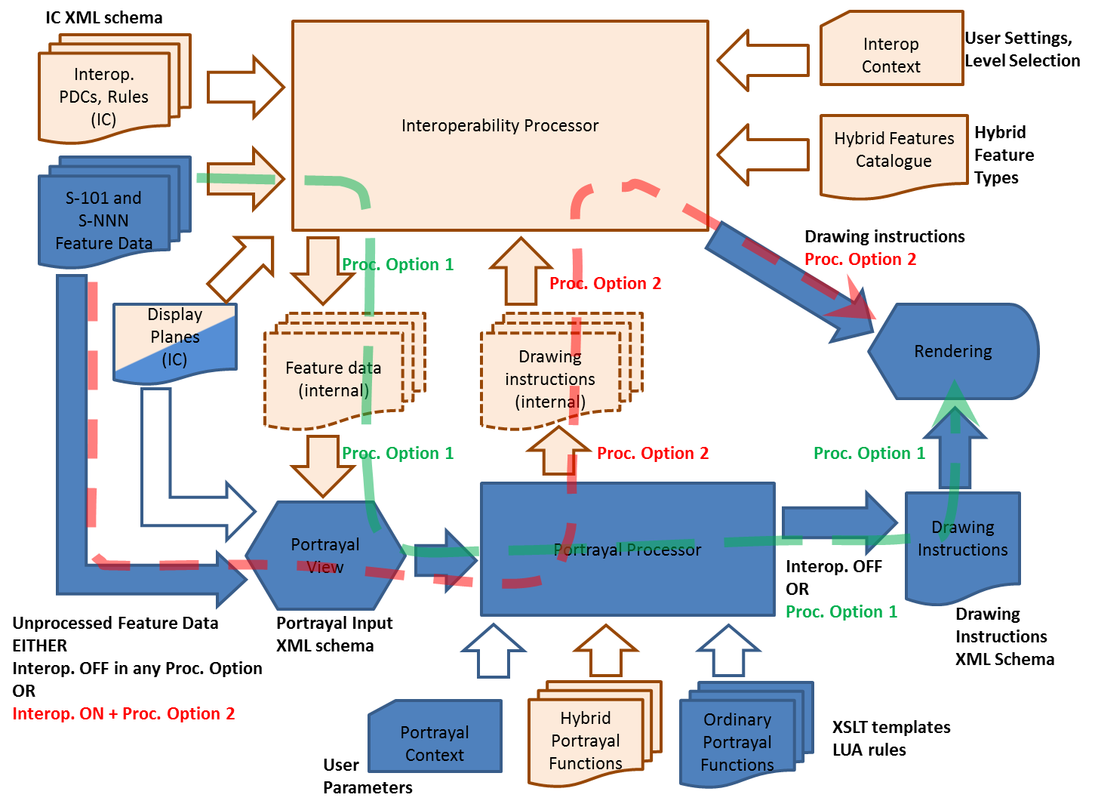

Figure 4‑9. Processing overview for complete interoperability catalogue

# Coordinate Reference Systems (CRS)

The interoperability catalogue does not have a CRS of its own, and it is therefore expected that the interoperability-ready product’s own CRS should be used by the viewing system to generate the portrayal. Product specifications created for the primary use in ECDIS is strongly recommended to use EPSG:4326 (WGS84) for CRS.

# Data Quality

Data quality in the individual dataset should be kept available and accessible by user selection, either portrayed in the chart pane or accessible via pick report. Amalgamating data quality between products is outside the scope of this specification and is not addressed in interoperability catalogues. See also section 10.7 for portrayal considerations.

# Performance Standards for ECDIS

IMO Performance Standards remains in effect, including standards about alerts and indications. ECDIS that implement this specification will still be subject to the rules and limitations put in place by applicable performance standards.

# How to make product specifications interoperable

This section gives guidelines for how to identify concepts that need to be factored into an interoperability catalogue, and suggestions for how to write rules to address associated interoperability issues. Moreover, these guidelines can be useful in the development of product specifications that will be included in an interoperability catalogue, in order to make these ready for interoperability in ECDIS.

For portrayal considerations, see section 10.

## Duplicated features

Perhaps the most significant issue to deal with when considering interoperability is how to deconflict duplicated features between layers. The following paragraphs deal with major categories of duplicate features.

Level 1 and Level 2 interoperability modes only permit creating rules that apply to all instances of a feature class, or subset of that feature class. Supressing or promoting single instances is reserved for interoperability Levels 3 and 4, which are outside of scope for this version of the interoperability catalogue specification.

### Duplicated features same model

Where there are equivalent models with same feature concept and attribute bindings, there still may be different attribute values due to issues with maintaining the same update sequence between different products. When considering this for the interoperability catalogue, priority should be given to the product that is most likely to be up to date with the latest information.

Developers of product specifications that are expected to be used in an ECDIS in interoperability mode should consider if the features within the specification are likely to be more frequently updated than those of the ENC or other products that may serve as a base layer or base layer combination for the product being developed. These considerations should be factored in when describing the production of the product and envisioned future use of the product.

IC_SuppressedFeatureLayer elements only have feature code and product as attributes for suppression, this means that all instances of a listed feature class will be suppressed. This is important to remember when creating rules that promote alternative instances. IC_Feature and IC_DrawingInstruction can have attribute combinations and spatial primitives to select the alternative instances. There is therefore, a risk that unless sufficient attention to details is given, important instances may be omitted.

EXAMPLE: If **Restricted Area Navigational** in ENC is suppressed, and **Restricted Area Navigational** with attribute **category of restricted area = 4 (nature reserve)** in Marine Protected Area dataset is promoted in its place, there is a chance that only instances with that combination will be visible, and all others supressed.

### Duplicated features, different models

Where the feature concept, attribute bindings, and values of selected attributes are mostly the same but there are minor differences in the different products, such as extra attribute bindings, the interoperability catalogue should consider which version of the feature is the higher value for the end user, and give that version priority. There may be different answers depending on the operational situation that the predefined combination tries to support, and this must be considered as part of constructing the interoperability catalogue.

EXAMPLE: Interoperability catalogue developers compare the specifications and data samples of **Pilot Boarding Place** features from a “Piloting Information” data product and the Pilot Boarding Place features in S-101 and decide that features from the “Piloting Information” datasets have more value in approach and harbour entry scenarios.

Developers of product specifications should consider how their data model is similar and/or different from other related product specifications, and the justification for this, and make recommendations to the developers of the interoperability catalogue for how to best select between their version of the feature and related features.

### Duplicate feature domains

Where feature concepts are different, but the information content is equivalent, considerations should include the update cycle of the information and when creating the interoperability catalogue priority should be given to the concept that is most likely to be updated most frequently. Other considerations should include any relations that the concepts has to other feature concepts, and consequences of breaking these must be considered when choosing which concept to give the priority and which concept to suppress.

EXAMPLE: Developers investigate the update cycles of real-time current data products and discover that they are updated more frequently than S-101 **Current – Non-gravitational** and **Tidal stream – flood/ebb** features, and features from the real-time current datasets are therefore preferred replacements for S-101 current features. Note that the question is decided not by comparing dates encoded in features, but on the basis of real-time data that is available on an ongoing basis vs. historical information gathered at a past date.

Product specifications developers should strive to maintain a data model that is as harmonized with related data models as possible. Due considerations should be taken before developing a concept that is different but functionally equal to similar concepts in other product specifications.

## Geometry

The geometry of a feature is a significant attribute that must be considered when developing the interoperability catalogue, as it defines the where-part of the feature object. Similar to other attributes, decisions may have to be made to address issues such as select one feature over another, e.g. where types in one product is affected by small scale, while another by large scale, or if merging the two is a better approach (only in interoperability Levels 3 and 4). The following paragraphs give more details about options for deconflicting geometry between products with the help of an interoperability catalogue.

### Combined geometry

Where there is a feature in one dataset that effectively augments the geometry of a conceptually different feature in another dataset, interoperability catalogue developers need to specify a hybrid feature with portrayal that can correctly portray the combined information. Moreover, it should be considered if it is appropriate for clarity in the navigation screen to supress the features in the origin datasets.

Example; dredged area augmented with high def bathy from survey of recent dredging operation giving more water and wider area than dredged area in ENC, combine to give a bigger (new boundary) dredged area than present in ENC.

The hybrid feature concept is only for interoperability Levels 3 and 4. Spatial hybridization/fusion is only available for interoperability Level 4. Both are out of scope for this version of the interoperability specification.

Developers of product specifications that may result in hybrid features when interacting with specific other products, should cooperate with the developers of the related product specifications to correctly define the conditions for appropriate use of hybrid features, and communicate these specifications to the interoperability catalogue developers.

### Spatial discrepancy, unrelated to scaled or cartographic smoothing

If the same feature instances in different data products are expected to have discrepant geometries, interoperability catalogue developers should establish the cause of the discrepancy. The cause will probably affect the solution implemented in the interoperability catalogue. For example, if one of the data products has more detailed information due to differences in the scopes of the product specifications, the interoperability catalogue developers should consider suppressing the feature class in the less-detailed product and preferring the same feature class in the product with greater detail. On the other hand, if the discrepancy is found to occur irregularly, it may be more appropriate to suppress the less-detailed instances and prefer the more-detailed instances, independently of the data products to which they belong.

Example: ENC has Restricted Area features, while MPA has Marine Protected Area features which show greater details and several sub areas with sub categories.

Developers of product specifications should examine the specification scope and consider if it is likely that resulting data products include information that will be better or worse than the same information in other products. For example, if information is only for contextual purposes, it is likely that better information is available in another product and in an interoperability ready ECDIS these contextual features should be supressed in the presence of more accurate information. Such expectations should be communicated with the interoperability catalogue developers who can then add appropriate rules to the interoperability catalogue.

### Spatial discrepancies, related to scale or cartographic smoothing

Where there is the expectation of differences of geometry for same feature instance in different products it is important to establish the cause, as this will likely impact the solution implemented in the interoperability catalogue. If the cause is related to scale or cartographic smoothing in one product over another due to issues such as different scopes (intended use) of the specifications, the interoperability catalogue developers should consider supressing the lesser detailed product and promoting the product with greater detail. If it is irregular occurrences of spatial discrepancies, it may be appropriate to supress the instances where there are less detail and promote the more detailed instances.

Example 1: ENC has approximate surface current instances using climatic data, Surface current gridded data has greater details and is daily updated.

Developers of product specifications should examine the specification scope and consider if it is likely that resulting data products include information that will be better or worse than the same information in other products. For example, if information is only for contextual purposes or is reduced in detail due to scale, it may be that better information is available in another product and in an interoperability ready ECDIS these lesser detailed features should be supressed in the presence of more accurate information. Such expectations should be communicated with the interoperability catalogue developers who can then add appropriate rules to the interoperability catalogue.

## Display of text

For details about display of text, including placement, display selection and management of long text. See section 10.8. The interoperability catalogue does not address these issues in general terms.

Developers of product specifications should be aware that the instructions they place within the product specification generally carry through even when the product is used in ECDIS in interoperability mode. Moreover, text placement issues in interoperability mode are expected to occur at the border between two products which may result in text being partially obscured due to priority issues. OEMs have long experience with solving such issues from S-57 ECDIS, and advice should be sought with them in how to mitigate such issues. Additionally, section 10.8 invites OEMs to provide functionality that seek to address most of the issues that cause text to be partially obscured.

## Skin-of-the-earth replacement

In interoperability mode, skin-of-the-earth replacement is a specialization of combined geometry, see section 8.2.1 for details. Also see sections 10.9 and 10.9.1 for portrayal considerations.

### Skin-of-the earth feature adjusting

In interoperability mode, skin-of-the-earth feature adjustment is a specialization of combined geometry, see section 8.2.1 for details. Also see sections 10.9 and 10.9.1 for portrayal considerations. Additional considerations should be given to the attributes of the resulting skin of the earth feature, as a combined feature may have altered geographical representation, attribute combinations or attribute values.

Example: Shoaling in a channel in an ENC may be indicated by high definition bathymetry, and a shallower channel hybrid feature replaces the ENC feature, which also has an amended shape. Depth areas adjacent grows due to the shoaling.

### Blended feature concepts

### Blended feature concepts or blended portrayals can be produced by using transparency between related features; or creating a temporary blended feature; or blended portrayal (rule and/or symbol) of specific combinations of features from different products. See section 10.9.2 for portrayal considerations and example of use case. Blended feature or blended portrayal are only possible in interoperability Levels 3 and 4. Such blended concepts will typically be created by using S100_IC_PredefinedCombination which link to a hybrid portrayal catalogue that include the features to be combined and a suppression rule, for example by using S-100_IC_SuppressedFeatureLayer, for the features that are to be replaced.

Developers of product specifications that are likely to be used in blended feature concepts by ECDIS in interoperability mode should communicate their intentions with developers of related specifications so that awareness is created about the inter-dependencies of these types of relationships. Such communication is especially important when revisions to these specifications are considered. Doing so will help manage risks to breaking the relationships as the related product specifications transition through their life cycle.

## Hierarchy of data

In this context, hierarchy of data means the stacking of data products (layers) within a predefined combination. Predefined combinations are generally created with a particular type of operational view in mind, and therefore the hierarchy of data may vary between predefined combinations. Typically, the ENC will be the base layer, i.e., the lowest layer in a predefined combination.

### Predefined combinations

Predefined combinations are used to define the hierarchy of data between different S-100 based specifications. An instance of IC_PredefinedCombination is associated to IC_DisplayPlane instances to give the hierarchy of the data products that are intended to be used. The attribute displayPriority within the IC_DisplayPlane gives the order in which the layers are drawn.

## New datasets

New datasets that that are added to an ECDIS with interoperability mode will be managed by any existing interoperability catalogue if the relevant data product is listed in it. Data producers should therefore perform sufficient tests to ensure new datasets perform as envisioned.

See section 8.8 for additional information about new data products.

### New datasets - coverages

New datasets may alter the available coverages of particular data that is used for interoperability views, and therefore any new dataset should be sufficiently tested to ensure performance is as envisioned.

### New datasets - max and min display scales

New datasets may alter the available data in particular scales and/or scale bands, for example, by adding or removing data coverage. Considerations should therefore be given to harmonization of maximum and minimum display scales when a new dataset is provided.

### New datasets - feature geometry

New datasets may alter the available feature geometry of available data that is used for interoperability views. Changes include extending or reducing size of areas, changing geometry type from area to point, point to area, area to line or line to area. Therefore, any new dataset should be sufficiently tested to ensure performance is as envisioned.

### New datasets - types and attributes

New datasets may change type and attributes of instances in the ECDIS, for example a platform may be removed and an obstruction remain. These changes may impact the situational view created by the interoperability catalogue as changes to feature classes and attribute combinations may mean objects are no longer covered by conditions specific to a predefined combination, or new objects are new covered. Therefore, any new dataset should be sufficiently tested to ensure performance is as envisioned.

## Dataset loading and unloading

Developers of product specifications and producers of data should make every effort to harmonize effects of maximum and minimum display scales at loading/unloading time between related product to control over-scale indicators and datasets, in order to avoid situations where one overlay is in scale but not another.

## New data products

When a new product is added to an existing interoperability catalogue, a new version will be required, see section 9.7. During the development of the new version, the interoperability catalogue developers should review existing predefined combinations for impact in addition to developing the new predefined combinations to manage the situational views that the new product is intended for.

## Metadata

This edition of the specification does not provide for comparing information that is not encoded as attributes of feature (or information type) instances. This means that metadata cannot be used in interleaving, filters, or rules unless it is encoded in feature attributes (e.g., “horizontal position uncertainty” attributes) or meta-features (e.g., Quality of Bathymetric Data). If product specification authors envisage a need to use metadata in interoperability, the application schema should be designed so as to make the relevant metadata available as feature attributes or meta-features.

Note that using information from meta-features in interoperability operations may involve spatial operations and thus require an interoperability catalogue to implement Level 3.

# Maintenance

This section describes the potential sources for change to an interoperability catalogue, together with the processes that should be considered when implementing a change to the interoperability catalogue.

## Maintenance and Update Frequency

Changes to this specification will be released by the IHO as a new edition, revision, or clarification, details of what constitute a new edition, revision, or clarification are found in section 1.5.1. This specification will be periodically reviewed by IHO at intervals of no less than 5 years for confirmation or update. New editions, revisions, and clarifications may be released more frequently as needed.

## Typical Sources of Change

Due to the nature of interoperability catalogues as a set of rules describing how a limited list of products are to interoperate within an ECDIS, the majority of all data sources for change will be from the listed supported products. Exceptions to this general practice will be when a new product specification is added to the list of supported products, along with changes to any relevant ECDIS related standards from IMO, IEC, and IHO that could be a source for change to an interoperability catalogue.

## Production Process

Interoperability catalogues are created in an XML editor environment. It is generally expected that any off-the-shelf XML Editor can perform this task. The creation process of any new versions may benefit from starting from the previous version. Another alternative is to develop a dedicated Interoperability Catalogue Editor that can create and maintain the Interoperability Catalogue with dedicated functions for creating the various components, such as display planes and predefined combinations.

Due to the interconnected nature of the product specifications that are under the interoperability schema, a form of overarching change management is a necessity. Any revision or new edition required in a product specification should be announced well in advance, giving the whole stakeholder community ample time to review the impact before it goes into effect. Any revisions and new editions to a supported product specification may require a new version of the interoperability catalogue and the IHO body responsible for the maintenance of the Interoperability Catalogue need to be informed and involved to assess any impacts. This includes updates to dataset metadata, as metadata changes, such as product specification references, may impact the link between the dataset and the interoperability catalogue.

## Management of FC and PC updates

Changes to a supported product specification may have impacts on the interoperability catalogue. Revisions to the feature catalogue or portrayal catalogue are the most likely to require a revision of the interoperability catalogue in order to support the change. These types of changes will generally require a new version (n.n.0) of the interoperability catalogue to ensure support. It should be noted that revisions to a supported feature catalogue or portrayal catalogue may be ignored by previous versions of the interoperability catalogue and it is therefore necessary to consider this as part of the change management process, especially if the change is a matter of navigational safety. Major changes to product specifications, such as adding functionality, or adding new product specifications to the supported list will result in a new edition (n.0.0) of an interoperability catalogue.

In cases of navigational safety, it may be necessary to issue a new edition of the interoperability catalogue in order to cancel previous versions and ensure all stakeholders and users are utilizing the most recent version.

Versions of the interoperability catalogue within the same edition are considered a compatible group. When a new edition is issued, this compatibility is broken, and efforts should be undertaken to update all impacted systems as soon as possible.



Figure 9‑1. Examples of how feature catalogue change may impact Interoperability Catalogue lifecycle

Several types of changes to supported product specifications may impact the interoperability catalogue in such a way that a new version is needed to maintain full support. These include:

* New feature added to a supported product specification that requires a new feature combination to be added to the interoperability catalogue.
* New attribute added to a feature in a supported product specification that requires a new attribute combination to be added to the interoperability catalogue.
* New product specification is added to the list of supported product specifications in the interoperability catalogue. This could also require new feature and attribute combinations to be added.
* Removal of feature or attribute from a supported product specification, and that are present in a feature or attribute combination within the interoperability catalogue.
* A correction to a supported product specification that triggers a version increment (n.**n**.0), which may break the link from the interoperability catalogue to the supported product specification.
* Matters of navigational safety as they arise.

New functions in either a supported product specification or the Interoperability Specification may require a new version of the Interoperability Catalogue.

## PS updates other than FC/PC

Updates to dataset metadata, such as product specification references, may impact the link between the dataset and the interoperability catalogue and therefore require a revision to the interoperability catalogue (n.**n**.0). Some changes to an interoperability-ready product specification may not require any changes to the interoperability specification or the interoperability catalogue. This includes amendments to the definitions of features, attributes or attribute values. It also includes minor changes to product specifications, such as clarifying language. Other changes may only require an update to the metadata of the interoperability specification and/or the interoperability catalogue, such as in case of supported product specification version references. Such minor changes to the interoperability specification and/or the interoperability catalogue may be collected and be applied at a later time when a more substantial revision is to be done anyhow.

## Unpredictable PS updates

Unpredictable changes to an interoperability-ready product specification, or its FCs and PCs should be avoided. Great care should be taken in coordinating changes among all stakeholders to avoid any unforeseen consequences. Product specifications that are under the ECDIS interoperability umbrella are interconnected and the responsible groups should therefore coordinate changes with other groups that issue interoperability-ready product specifications. Such coordination can be done, for example, by having an agreed fixed period between releases in which all pending changes are collected, implemented and issued in a coordinated fashion.

If a situation arises where a product is not compatible with the IC, this product will only be available in interoperability mode Level 0. Meaning as an overlay that may obscure any data below the incompatible product, and the overlay may be obscured by any data with higher priority.

## Additional data products to be defined in catalogue

The interoperability catalogue should in theory be extensible to products not yet defined, provided these are within the same S-100 Edition. New products can be included in the catalogue, but such scenarios will require a new edition of the Interoperability Catalogue. The default processing for any interoperability catalogue is that any new product follows the default rules in interoperability Level 0. This means with default viewing groups are in effect, and user selected stacking when there are two or more new products displayed on the screen simultaneously.

## Backward compatibility

Different versions of data products may be simultaneously active, the Interoperability Catalogue design allow for backward-compatible updates if and when the Interoperability Catalogue has to be updated, within the same major edition. Figure 9-2 shows an example of how the Interoperability Catalogue may evolve with change over time.

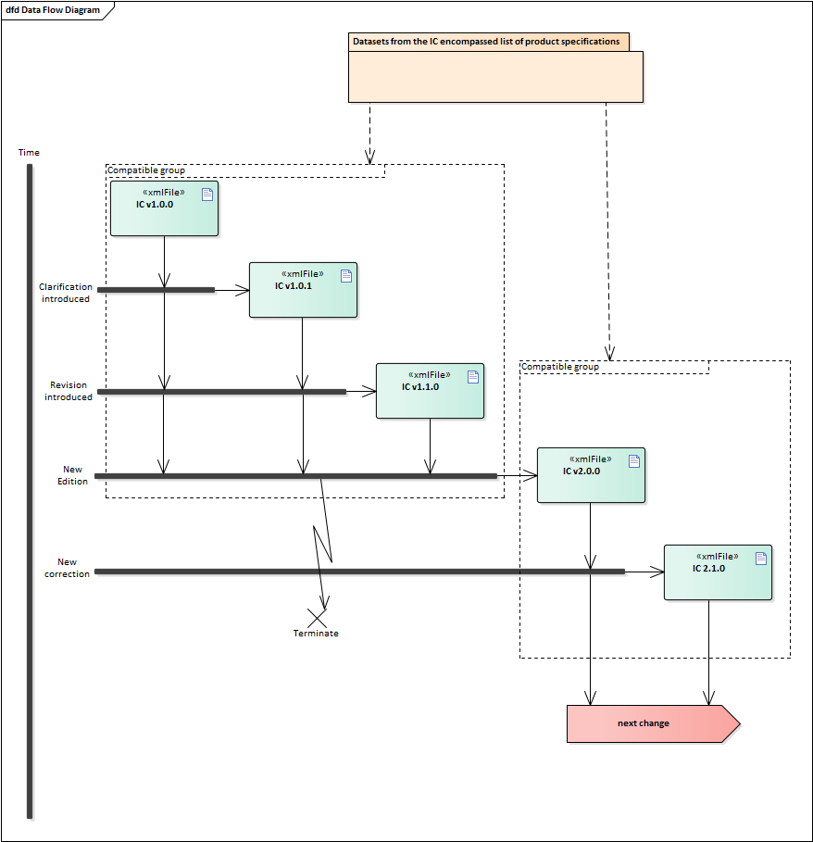

Figure 9‑2. Example life cycle of Interoperability Catalogue

# Portrayal

This section gives guidelines and instruction to portrayal considerations related to the use of the interoperability catalogue in an ECDIS. The interoperability catalogue must apply to the specific product specifications listed in the interoperability catalogue metadata, interoperabilityCatalogueProducts attribute under S100_IC_CatalogueMetadata.

There may be additional data products present in the S-100 ECDIS that are external to the interoperability catalogue, in such cases the interoperability catalogue should continue to function in presence of product not defined in the catalogue. Data products that are outside of the interoperability scope must be treated in Interoperability Level 0 (see section 9.7).

## Display of significant features

Significant features in a display plane should have the highest displayPriority value within the S100_IC_DisplayPlane. Care should also be given to assigning significant features with high drawing order values within the relevant S100_IC_Feature and S100_IC_DrawingInstruction. This ensures that less significant features in one data product are not displayed more prominently than more significant features in another product.

## Display of significant features - switching to original

Users must be provided means to easily switch on and off the interoperability function and display only the ENC data.

## Portrayal distinguishability - colour set-asides

Special consideration must be made when creating portrayal rules related to colour choices for a product specification that is on the list of ECDIS relevant product specifications. S-101 ENC portrayal follow the rules laid out in S-4, where it is stated that certain colours have specific meaning. For example, S-4 gives indications for magenta line meaning something non-physical, while black line means a physical item. See IHO S-4 B-141 to B-145 for additional details.

On ENC the light sectors marking intricate inshore channels in for example Scandinavian waters are shown in red, green, and yellow.

### Black (S-4 B-141)

Black is normally used for all physical (solid) features, including depth information (see S-4 B-142.2(2)) for submarine cables and pipelines and S-4 B-144 for some depth contours.

### Magenta (S-4 B-142)

The general principles for the use of magenta are that it should be reserved for:

* Drawing attention to symbols for features which have a significance extending beyond their immediate location.
* Distinguishing information superimposed on the physical features and not implying any permanent physical obstruction (see S-4 B-145 for the use of green for environmental information).

### Buff (yellow) or grey (S-4 B-143)

A colour, usually buff (yellow) or grey, must be used as a land tint in paper charts. ENC portrayed with S-52 in an ECDIS uses a yellow/brown colour (LANDA).

### Blue (S-4 B-144)

The colour blue has been used as a tint to emphasize **shallow water.** Two (or more) densities of blue tint may be used to show different depth bands of shallow water, the darkest tint showing the shallowest water.

### Green (S-4 B-145)

The colour green may be used as a tint for inter-tidal areas. Green may also be used, instead of magenta, for environmental information and limits; see S-4 B-437.2b.

### Red

It should be noted that any symbology using red may be an issue for ECDIS operated in night mode, and therefore the use of red should be avoided as much as possible.

## Day/night/dusk modes

It is required that every product specification that is included in the supported list has colours specified for day, dusk, and night modes. The system must utilize these colours depending on the mode the viewing system is set to.

## Impacts on viewing groups

The viewing group is a concept to control the content of the display. It works as an on/off switch for any drawing instruction assigned to the corresponding viewing group. The concept can be seen as a filter on the list of drawing instructions [S-100, 9-11.1.3].

Interoperability catalogue viewing groups take precedence over the applicable viewing groups for those feature instances in a supported product specification, and that are included in a S100_IC_DrawingInstruction or S100_IC_Feature instance.

## Impacts on portrayal catalogues

Viewing systems must manage the visibility and display priority of data products, especially relative to radar/ARPA or AIS display. Moreover, systems must ensure significant features with over radar flag, in all products are distinguishable in the presence of radar/ARPA and AIS. Tracks and vessel position information are high priority but AIS ASM (application specific messages) may carry lower-priority information, including data described by an S-100 based product specification (e.g., meteorological and hydrographic information as described in S-104).

## Meta-features

In general, the viewing system should allow display of meta features for only one product at a time. This is in order to minimize display clutter, user confusion, and the possibility of interpreting meta-features for one product as applying to a different product.

This means, for example, that data quality meta features for different on-screen products should not be displayed simultaneously, and that only the top most product data quality should be shown at any given time. This also applies in areas of the screen where the topmost product does not cover.

### Data quality for individual products

This section applies to the case where multiple products are on-screen and quality meta-features are enabled. Only one set of quality features should be displayed at any given time to avoid clutter and misreading the meaning of the quality metadata.

Interoperability catalogues do not specify means of distinguishing data quality portrayals for individual products. Product specifications must provide rules for display of data quality metadata (including data quality meta-feature information), which the ECDIS will used to portray data quality.

Means of distinguishing data quality portrayals for individual products is left to the product specification authors (in particular, portrayal catalogue authors) and OEM, and can be handled by distinguishing portrayal rules or symbology for different products’ data quality meta-features, such as colour coding or special line symbol. There should also be a clear on-screen message saying what data quality features are displayed in order to give users a firm indication of the layer to which the currently displayed quality metadata applies.

### Portrayal of data quality for combinations

Interoperability catalogues do not include combining data quality portrayals. The recommendation in section 10.7 about displaying only one set of meta-features is strengthened for data quality in particular. This specification recommends against simultaneous portrayal of data quality from different products.

Since ENC data is expected to be the base layer in most, if not all, combinations, the ENC data quality may not be shown if only top layer data quality is displayed. This would force users to turn off all other layers in order to see ENC data quality features on the graphic display. It is therefore recommended that OEMs include functions to let the user select which product’s data quality should be displayed.

## Display of text

Text is typically the last item drawn, before own ship. In general, rules for placement, display selection, and management of long text are defined in the individual product specification. The interoperability catalogue would, in general, only govern when a feature that text is generated from is displayed.

Viewer systems should ensure that text never overlaps significant features that are of navigational significance, specifically dangers (e.g. obstruction, wreck, rock) that are shallower than the mariner's safety contour, or an aid to navigation.

If the centre of the text bounding box falls outside of the dataset area, then it must not be drawn.

OEMs may add functions for enhanced automatic text placement.

## Skin-of-the earth replacement

Skin of the earth replacement within the sense of interoperability depends on the interoperability level chosen. Common among all the levels is that anything that replaces S-101 skin of the earth features, will overwrite it by having a higher priority, i.e. drawn later. The major difference between the levels is in the overwriting, where the lowest level overwrites skin of the earth features and everything else, while the subsequent levels permit interleaving, replacing or merging of features from different products creating hybrid features.

Gridded data will generally go over ENC and obscure ENC features, either all (interoperability Level 0) or specific features (interoperability Levels 1 or 2) depending on interoperability level chosen, the predefined combinations or display plane of the features that are interacting.

Example 1: High definition gridded bathymetry replaces (overwrite) depth area and depth contours, but soundings, aids to navigation, and obstructions are over the high definition bathymetry (interoperability Level 1).

Example 2: Surface current gridded data goes over ENC and replaces all surface current features (interoperability Level 2).

Safety contour comes from ENC and is generated by viewer system. This safety contour is an IMO requirement (IMO Performance Standard 5.8 (MAS.232(82))) for ECDIS and should be presented with highest priority when turned on by the user. OEMs are permitted to add additional safety contour functions, for example; generated from combining high definition gridded bathymetry (S-102) and S-104 input.

### Skin-of-the earth feature adjusting

This section covers the possibility of the skin of the earth features geometry and/or attribute values being dynamically adjusted based on the corresponding features in other data layers.

Changes to the location or extent of symbols displayed on the screen due to a feature in another dataset are only possible in interoperability Levels 3 and 4. These changes effectively augment the geometry and/or attributes of a conceptually different feature in another dataset (though the nominal value remains unchanged). E.g., surface or sea-floor ice may effectively change the geometry of safety contours, by reducing the extent of safe water or affecting depths and underkeel clearance in ways that depend on vessel characteristics and icebreaker activity.

### Blended feature concepts or blended portrayals

This section describes the interoperability solution for blended feature or blended portrayal. These can be produced by using transparency or creating a temporary blended feature or blended portrayal (rule and/or symbol) of specific combinations of features from different products. Blended feature or blended portrayal are only possible in interoperability Levels 3 and 4. Such blended concepts will typically be created by using S100_IC_PredefinedCombination which links to a hybrid portrayal catalogue that includes the features to be combined and a suppression rule (using S-100_IC_SuppressedFeatureLayer) for the features that are to be replaced.

An example where a blended concept could be used is where winds blowing from the west cause fairways to some west coast ports of Finland to get layered ice (wind pushes ice layers on top of each other until there is ice from the sea bottom up to the surface). When an ice-breaker makes a path through some ice remains between the sea bottom and the keel of the ice-breaker. Ice thickness in such a place could be up to 11 m while the ice-breaker draught is around 7-8 meters. In such cases a simultaneous display of both ice coverage and underlying depth area is required. Other depth area features such as spot soundings, rocks, wrecks, etc., are also still important.

## Blended portrayals

When combining various layers, that may be of different compilation scale and coverage, it is likely that symbols and area patterns will end up at borders, or conflict with symbols and area patterns in other layers. It is important that symbols remain legible, and that OEMs use appropriate methods to avoid displaying partial symbols, or “grafting” part of lower-layer symbols onto symbols in upper layers.

For area fills the symbols of a pattern fill must be closer together for a small or narrow area, to ensure enough symbols are seen, and farther apart for a large area, to avoid clutter. An area pattern may be substituted by a single centred symbol if sufficient space is not available for a pattern to be shown.

## Hierarchy of data

Hierarchy between different product specifications can be influenced by several factors such as intended use and navigational operation. It may not be possible to prescribe a fixed hierarchy list as a universal standard, and the interoperability catalogue model therefore offers a flexible approach. Within the interoperability catalogue the hierarchy of data between different S-100 based specifications is determined using predefined combinations. The DisplayPlanes referenced within a PreDefinedCombination give the order of feature layers.

### Interacting gridded information

If two or more gridded data types are to interact, the hierarchy between them should be established using predefined combinations as with other data types. Particular care has to be taken depending on how the presentation of the data is to be done when deciding which gridded data type has the highest priority, considering items such as will one gridded data type obscure the other.

For example; gridded bathymetry will likely obscure gridded surface currents, and therefore the gridded surface currents should be given the highest priority between the two if they are to be displayed simultaneously.

## Pick reports

Pick reports are typically defined in the individual product specification. The interoperability catalogue permits reuse of these specifications as it does not specify pick report design for the individual supported product specification. This specification rather outlines the general principles that apply to pick reports when a system is used in interoperability mode.

### Combined pick reports

In interoperability mode, pick reports should be combined into one pick report that contains information from all underlying products. A tree structure should be presented to the user, where the top most layer is the open branch, and the lower layers are closed branches, by default, but can be expanded by the user as required. Each branch should support the particulars of the product specification that is represented by that branch.

Means must be provided to distinguish which product a feature comes from, for example the product can be used as a “namespace prefix” for attributes or objects.

S-101: RestrictedAreaNavigational:…  
S-122: RestrictedAreaNavigational:…

Pick reports may create a display that combines attributes from features from different products, and it should then be possible to distinguish where the attribute is from. For example, the method below may be used.

RestrictedAreaNavigational  
S-101: restriction:…  
S-122: restriction:…

OEMs may include a common pick report style for the whole tree.

### Prioritized pick reports

Pick reports should be prioritized in the order of layer stacking, with the top most layer on top and the lower layers made available in succession below.

### Full information availability

Complete data from all products on the screen must be available to the ECDIS user, irrespective of all these products being in the scope of the interoperability catalogue or not.

Features that have been suppressed must be included in the pick report, and must to be clearly marked as suppressed features.

In interoperability Levels 3 and 4, hybrid features much be present in the pick report and marked as hybrid features.

## User control over loaded set

Users must always have the option to load an additional product, or turn off one or more of the data products in a predefined combination. Portrayal must adjust to the loaded set as appropriate, e.g., if an additional product is loaded, it should be interleaved with layers from data products in the predefined combination according to the drawing priorities and drawing order in its portrayal catalogue.

The user interaction aspect of user control over loaded data products are discussed in section 15.6.

## User control over interoperation level

Users must always have the option to select the interoperability levels they wish to use. Only predefined combinations that correspond to the levels chosen should then be available to the user. Alternatively, the user should be warned if picking a predefined combination that is not among the interoperability levels already selected.

The user interface aspects of user control over interoperation level are addressed in section 15.7.

# Data Product format (encoding)

## Introduction

Format Name: XML

Version: 0.3-YYYYMMDD

Character Set: UTF-8

Specification: (This document.)

The data format version is of the form <edition>.<revision>-<build> (or <edition>.<revision>.<clarification>-<build>). The <edition>.<revision> sequence will be the same as the corresponding components of the interoperability specification version. (The <clarification> component is optional, but if present will be the same as the clarification component.) The YYYYMMDD component is a build date for the XSD files which constitute the machine-readable data format description. This format allows harmonization of the version numbering of the XSD files and this specification. (Clarifications to the specification will generally not require changes to the XSD files, but if they do, a new set with <clarification> and new <build> date will be issued.)

## Unknown Attribute Values

When a mandatory attribute code or tag is present but the attribute value is missing, it means that the producer wishes to indicate that this attribute value is unknown. Missing mandatory attributes must be “nilled”. Optional attributes must be omitted altogether if the value is unknown or missing. They must not be “nilled”. This rule also applies to metadata.

## XML schemas

### Overview

This data format consists of a root or container element S100_IC_InteroperabilityCatalogue, whose structure is shown in Figure 11-1. An interoperability catalogue contains header information identifying the catalogue (derived from the ISO abstract catalogue type and extended with specific elements appropriate to S-100 and interoperability, such as digital signatures and elements identifying the source of interoperability requirements for this catalogue). The header is followed by a list of products covered by the catalogue and containers for display planes and predefined combinations. Levels 1 and 2 catalogues will contain only display planes and predefined combinations. Level 3 and 4 catalogues will have additional containers for hybridization rules and references to the hybrid portrayal and feature catalogues used by the results of hybridization rules. The general structure is depicted in Figure 11-1.

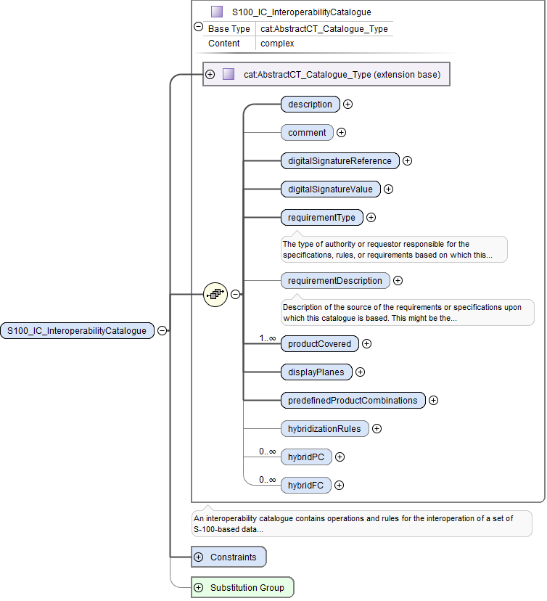

Figure 11‑1. Basic structure of an interoperability catalogue

The displayPlanes container is a collection of 1 or more S100_IC_DisplayPlane elements. The predefinedProductCombinations container is a collection of 0 or more S100_IC_PredefinedCombination containers. (The difference in the lower bound arises from the fact that it is possible for a catalogue to implement only interleaving but no higher level of interoperability.) The containers are depicted in Figure 11-2 and Figure 11-3.

|  |  |
| --- | --- |
| Figure 11‑2. Container for display planes | Figure 11‑3. Container for predefined product combinations |

The elements in each S100_IC_DisplayPlane and S100_IC_PredefinedCombination correspond to the model described in Section 4 and are depicted in Figures 11-4 and 11-5. The contents of these elements are as described below:

* S100_IC_DisplayPlane element:
  + the priority for the plane (displayPriority);
  + identifying and descriptive elements (identifier, name, description);
  + containers for S100_IC_Feature and S100_IC_DrawingInstruction elements.
* S100_PredefinedCombination element:
  + the interoperability level;
  + a list of the data products covered by this predefined combination (includedProduct elements);
  + references to S100_IC_DisplayPlane elements;
  + optional containers for feature suppression rules (used in Level 2) and feature derivation rules (Levels 3 and 4);
  + identifying and descriptive elements (identifier, name, description, useConditions).

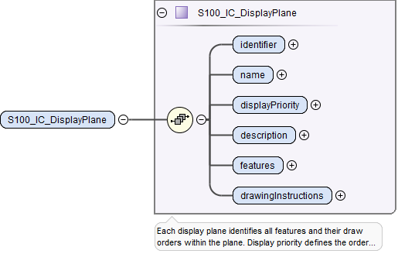

Figure 11‑4. Structure of individual display plane element

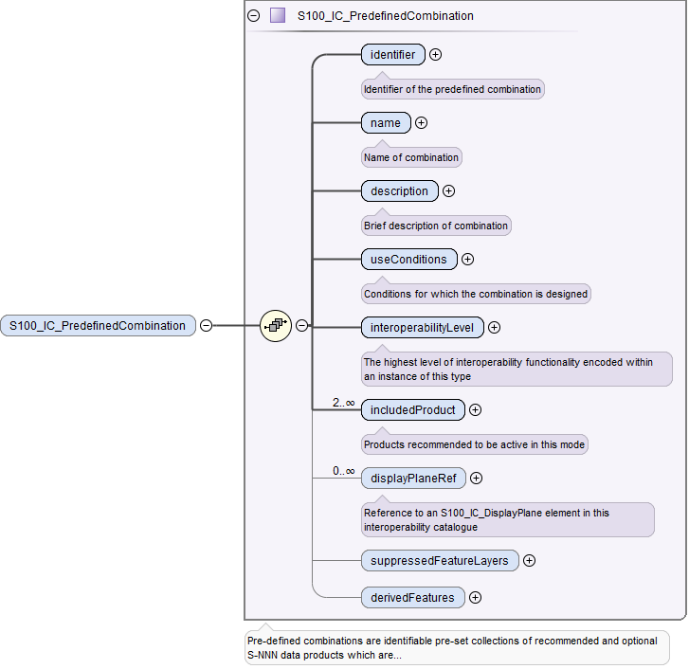

Figure 11‑5. Structure of individual predefined combination element

The structures of S100_IC_Feature, S100_DrawingInstruction, and S100_IC_SuppressedFeatureLayer elements correspond to the model and documentation in Section 4 and are depicted in Figure 11-6, Figure 11-7, and Figure 11-8. The elements in the derivedFeatures container are intended for Level 3 and 4 functionality and are not described in this edition of the specification.

|  |  |
| --- | --- |
| Figure 11‑6. Structure of S100_IC_Feature | Figure 11‑7. Structure of S100_IC_DrawingInstruction |

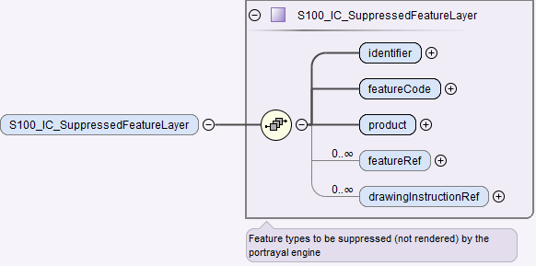

Figure 11‑8. Structure of S100_IC_SuppressedFeatureLayer

An example of the XML conforming to the structures is shown in Figure 11‑9. This figure shows the higher-level structure consisting of the catalogue header elements (*cat:name* through *requirementType*), followed by exemplary display plane and predefined product combinations. The lower-level containers *features*, *drawingInstructions*, and *suppressedFeatureLayers* are shown expanded in Figure 11-10 and Figure 11-11.

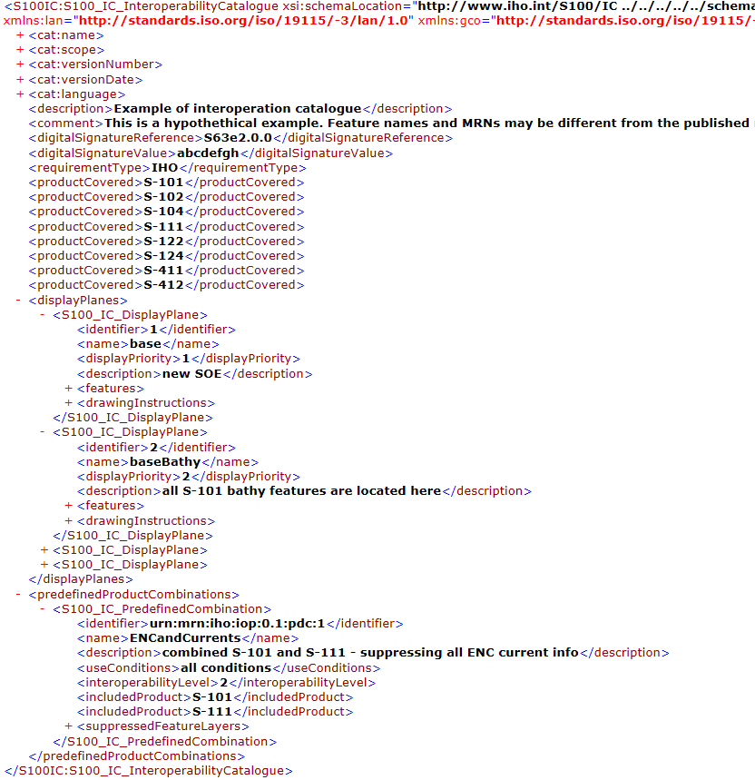

Figure 11‑9. Example of interoperability catalogue showing the higher level structure

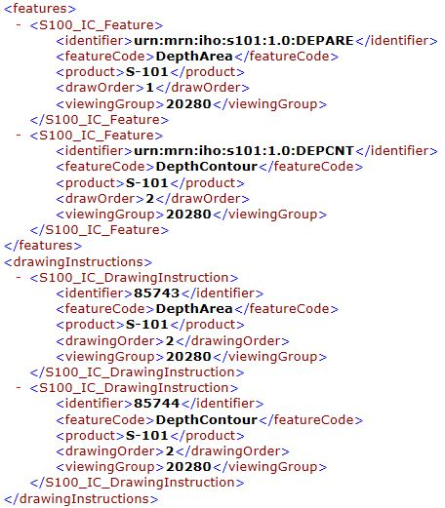

Figure 11‑10. S100_IC_Feature and S100_IC_DrawingInstruction - XML examples

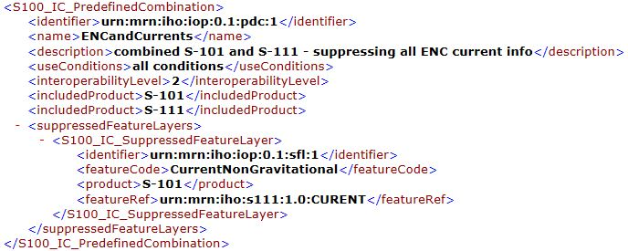

Figure 11‑11. S100_IC_PredefinedCombination and S100_IC_SuppressedFeatureLayer - XML examples

Figure 11-12 shows an expanded example of a display plane derived from S-101 showing one of the display planes for S-101 – this one contains navigation aids. The specification for one feature has been expanded as an example. As described earlier in this specification, the drawing order and viewing group given in the portrayal catalogue can be overridden for interoperation purposes by different values encoded here, on a per-feature (type) basis.

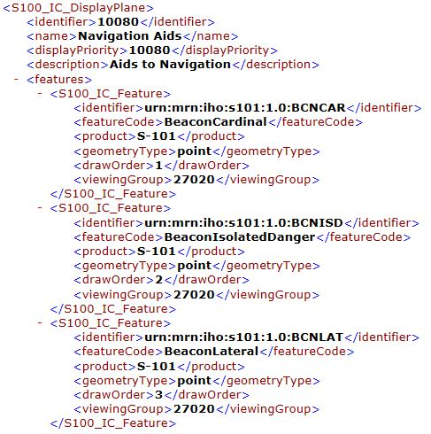

Figure 11‑12. Example of display plane with S-101 features (informative)

The figure below depicts the use of the substitution capabilities of the interoperability catalogue. The element substituteSymbolization for S-101 feature CurrentNonGravitational has its point and line symbols replaced by new symbols which are identified inline. (The symbol and linestyle files are hypothetically included in the portrayal catalogue identified by IHOICPCEXMP0001.)

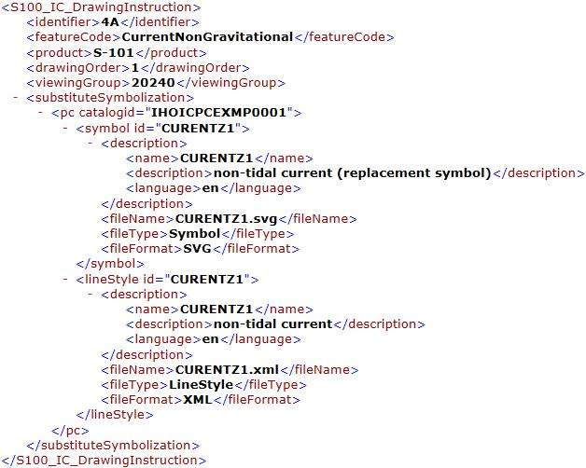

Figure 11‑13. Example of substitution in a drawing instruction (informative)

The content of *substituteSymbolization* may be encoded as an ordinary (non-XML) string, e.g., a code fragment in some domain-specific language. This specification does not prescribe any requirements for the content of *substituteSymbolization* other than the syntactical constraints listed below:

1. If the content is XML, it must be well-formed (e.g., have balanced opening and closing tags).
2. A CDATA section may be used to avoid having to use replace characters of special significance in XML (e.g., “<” and “&”) with character entities.

### Location of schema files

The schema files are available from the locations listed in Table 28.

Table 28. Schema files locations

|  |  |  |  |
| --- | --- | --- | --- |
| **File** | **Description** | **Version** | **Location** |
| S100_IC.xsd | XML schema for interoperability catalogue | 0.3 | https://github.com/IHO-S100WG |
| S100_IC.sch | Schematron file for validating interoperability catalogue | 0.3 | https://github.com/IHO-S100WG |

Note: The XML schema as distributed imports ISO metadata schemas from the ISO Internet location encoded in the S100_IC.xsd file. Implementers may wish to store the ISO metadata schemas locally and use the local installation instead.

# Data Product Delivery

## Introduction

This section specifies the encoding and delivery mechanisms for an interoperability catalogue. Data which conforms to this product specification must be delivered by means of an exchange set as specified in this section.



Figure 12‑1. Exchange Set Structure for base catalogue set



Figure 12‑2. Exchange Set Structure for update catalogue set

Units of Delivery: Exchange set

Transfer Size: Unlimited

Medium Name: Digital data delivery

Other Delivery Information:

The interoperability catalogue exchange set has a single exchange catalogue which contains the discovery metadata for the interoperability catalogue and any associated support files.

A base set must have an interoperability catalogue present, while an update set must have at least one of an interoperability catalogue, a hybrid feature catalogue or a hybrid portrayal catalogue.

An exchange set may be encapsulated into a form suitable for transmission by a mapping called a transmission encoding. An encoding translates each of the elements of the exchange set into a logical form suitable for writing to media and for transmission online. An encoding may also define other elements in addition to the exchange set contents (i.e., media identification, data extents etc…) and also may define commercial constructs such as encryption and compression methods.

If the data is transformed (e.g., for encryption or compression purposes) its content must not be changed.

### Interoperability Catalogue in different formats

The interoperability catalogue may be substituted by equivalent catalogues or presentations developed by manufacturers or service providers, provided the minimum functions are maintained and the producer of the replacement interoperability catalogue can prove this through testing.

### Extending the Interoperability Catalogue

The interoperation catalogue will be extensible with equivalent rules or presentations developed by manufacturers or service providers, provided the minimum functions are maintained and the producer of the augmented interoperability catalogue can prove this through testing.

### Customization - OEM/integrator

OEM or service providers can provide their own versions in addition to the IHO catalogue, to facilitate custom product interoperations. These additional versions must not degrade or interfere with the functions of the official IHO Interoperability Catalogue.

## Interoperability Catalogue product

Each Interoperability catalogue product is by itself a whole unit. New versions – either clarification, correction, or new edition – are updated by replacement with a newer version.

### Interoperability Catalogue size

There is no size limit for interoperability catalogue products, however, compression is used to reduce the exchange set size.

### Interoperability Catalogue exchange set compression

An interoperability catalogue exchange set must be compressed using one of the appropriate algorithms listed in S-100 4.X Part 15.

### Interoperability Catalogue file naming

Interoperability catalogues must follow the naming convention below, where the main part forms an identifier where:

IHOICXXXXXX.XML

* the first three characters must be IHO - for International Hydrographic Organization as the issuing organization.
* the fourth and fifth characters must be IC - for Interoperability Catalogue
* the sixth to eleventh characters is for the version number to ensure the file name is globally unique. Version 1 would be 010000 [01.00.00].

The extension must always be .XML.

## Support Files

Interoperability Levels 3 and 4 may require support files in the form of hybrid feature catalogues and hybrid portrayal catalogues. Methods for managing these are described below.

### Support File Naming

IHOICCCXXXXXXXX.XML

Support file names must follow the naming convention below:

* the first three characters must be IHO - for International Hydrographic Organization as the issuing organization.
* the fourth and fifth characters must be IC - for Interoperability Catalogue
* the sixth and seventh characters must be FC for feature catalogue or PC for portrayal catalogue
* the segment from the eighth to fifteenth characters is for a globally unique alpha numeric code. The following characters are allowed in the support file name, A to Z, 0 to 9 and the special character _ (underscore). Fewer than eight characters may be used in this segment.

The extension must always be .XML.

### Support File Management

When a support file is created or a subsequent version is issued it must carry its own issue date and be supported with a digital signature which authenticates it against the IHO’s public key included in the exchange set metadata.

The type of support file is indicated in the “purpose” field of the discovery metadata. Support files carrying the “deletion” flag may be removed from the ECDIS.

Support files should be stored in a separate folder within the exchange set.

## Exchange Catalogue

The exchange catalogue acts as the table of contents for the exchange set. The catalogue file of the exchange set must be named CATALOG.XML . No other file in the exchange set may be named CATALOG.XML. The contents of the exchange catalogue are described in section 13 (Metadata).

The exchange catalogue format is described by an XSD file that extends the S-100 exchange catalogue schema. The exchange catalogue XSD file will be made available at the IHO schema distribution location (currently https://github.com/IHO-S100WG).

## Encryption and authentication

### Encryption method

Data Encryption is not mandatory, however if it is required then it must comply with the mechanisms provided in S-100 4.X Part 15. Part 15 also allows dataset files to be compressed using the zip algorithm (see 12.2.2) prior to encryption. Details are provided in S-100 Edition 4.X Part 15.

### Digital signature

In addition to the metadata included for each dataset file, its digital signature, an exchange set must also provide a public key from IHO. The public key is termed “public” because its existence is not kept confidential. Each producer’s public key is included in a “publicKeys” field within the exchange set. These keys are referred to by the digital signature.

Authentication is done in two stages;

1. verifying that the public key information included in the exchange set validates correctly against the IHO’s root level certificate
2. Verifying that the data in the exchange set has not changed and the file based digital signatures are valid against the producer’s public key.

The IHO’s root certificate (certifying the IHOs identity) should be held externally on the implementing system and is not part of the dataset metadata.

The interoperability catalogue is issued by IHO, and is therefore self-signed.

### Authentication

Authentication is done as described in S-100 Edition 4.X Part 15. This describes how to define a public/private keypair specific to the producer and how a data producer or distributor is able to have their identity (as embodied in the public / private keypair) certified by the IHO acting as the data protection scheme administrator

### Integrity checks for the interoperability catalogue.

To ensure the Interoperability Catalogue has not changed during transmission/delivery integrity checks are performed via a Digital Signature as defined by S-100 Edition 4.X Part 15. File integrity checks are based on the Digital Signature Algorithm (DSA) as defined in the Federal Information Processing Standard FIPS 186-4.

The Interoperability Catalogue discovery metadata includes a mandatory field for each included file’s digital signature called “digitalSignatureValue”. This contains a base64 encoding of the hexadecimal numbers comprising the digital signature itself. The content of these fields is defined, along with the algorithms for their calculation, in S-100 4.X Part 15. This also defines how chains of signatures may be defined. The digital signature uniquely authenticates the dataset content against the individual producer’s public key issued and authenticated by the IHO. The combination of the digital signature, the file and the producer’s identity allows the end user to be assured of the origin and integrity of the Interoperability Catalogue.

## Updating the Interoperability Catalogue

Several versions of the interoperability catalogues may be active at a given time due to backward compatibility within each major edition. This compatibility is likely to be broken when a new edition is released. See section 9 for more details on interoperability catalogue maintenance.

### Updating the Interoperability Catalogue

Interoperability catalogues may remain active after a new version has been issued. Systems receiving new versions within the same major edition should retain all versions. Store these in separate folders to avoid any issues, such as when the same support files have been reused between versions.

Due to issues with broken backwards compatibility, all previous versions of the interoperability catalogue should be cancelled when a new edition is issued.

### Cancelling a version of the interoperability Catalogue

In order to cancel a version of the interoperability catalogue, a cancellation catalogue file is created for which the edition number must be set to 0. Interoperability catalogue edition number is a field in exchange set metadata, class S100_IC_CatalogueMetadata (see section 13 on Metadata classes). The cancellation catalogue file may contain no data objects and any data objects present it in are ignored. The cancellation catalogue file may be part of an exchange set which contains a new version of the interoperability catalogue. This method is only used to cancel an interoperability catalogue. When a version of the interoperability catalogue is cancelled it must be removed from the system.

A cancellation applies only to interoperability catalogues meeting the following conditions:

* The issue date and time of the interoperability catalogue being cancelled precede the issue date and time of the cancellation itself. Issue date and time are fields in S100_IC_CatalogueMetadata (see Table 32).
* The version date of the interoperability catalogue being cancelled precedes or coincides with the version date of the cancellation interoperability catalogue. Version date is a field in the interoperability catalogue header (see Figure 4‑3 and Table 9).
* The producer of the cancellation has the authority to cancel the original.

Note 1: The issue date in metadata may or may not be the same as the version date in the catalogue header.

Note 2: Verification and management of authority relationships is out of the scope of this specification, and may have to be an external process (e.g., verification of signatures and verification that issuer and canceller are the same or successor organisations, or belong to the same or successor organisations).

### Updating the Interoperability Catalogue support files

Support files are updated using the method detailed in section 12.3.2.

If changes occur to the support files of a version of the Interoperability Catalogue, then the updateApplicationDate in S100_IC_CatalogueMetadata must carry the date of the change.

#### New Edition of the support files

New Editions of the support files introduce significant changes. New Editions enable new concepts, such as the ability to support new functions, or the introduction of new constructs. New Editions are likely to have a significant impact on either existing users or future users of the Interoperability Catalogue specification.

EXAMPLE: A new product is added to Interoperability Catalogue, and all support files should be updated to support the new product. This would require a new edition of the support files.

#### Revisions to the support files

Revisions are defined as substantive semantic changes to the support files. Typically, revisions will change the support file to correct factual errors; introduce necessary changes that have become evident as a result of practical experience or changing circumstances. A revision must not be classified as a clarification. Revisions could have an impact on either existing users or future users of the Interoperability Catalogue specification. All cumulative clarifications must be included with the release of approved corrections revisions.

Changes in a revision are minor and ensure backward compatibility with the previous versions within the same Edition. Newer revisions, for example, introduce new feature or attribute combinations. Within the same Edition, a support file created for an interoperability catalogue of one version could always be processed with a later revision of the Interoperability Catalogue.

EXAMPLE: Adding a new hybrid feature will require a revision increment to the support file.

#### Clarification to the support files

Clarifications are non-substantive changes to the support file. Typically, clarifications: remove ambiguity; correct grammatical and spelling errors; amend or update cross references; insert improved graphics in spelling, punctuation and grammar. A clarification must not cause any substantive semantic change to the Interoperability Catalogue specification.

Changes in a clarification are minor and ensure backward compatibility with the previous versions within the same Edition. Within the same Edition, a support file created for an interoperability catalogue of one version could always be processed with a later clarification (or revision) of the Interoperability Catalogue.

EXAMPLE: Correcting a spelling error in a definition will require a clarification increment to the support file.

#### Version Numbers

The associated version control numbering in the support file headers must follow the same structure as the product specification itself, see section 1.5.1.5. Support files need not follow the version number of the interoperability catalogue they belong to, as support files may be updated numerous times between versions of the interoperability catalogue.

Version numbers of support files may have a suffix that indicates a “build number” or date of creation or issue of the support file.

# Metadata

## Introduction

Discovery metadata for interoperability catalogues must be provided in XML format conforming to S-100 dataset discovery as specified in S-100 Part 4a, with the extensions described in this section.

## Language

Interoperability catalogue metadata must be provided in the English language.

## Interoperability Catalogue Metadata elements

Each exchange set has a single CATALOG.XML file which contains meta information for the data and support files in the exchange set.

Table 29. S100_ExchangeCatalogue

| **Role Name** | **Name** | **Description** | **Mult** | **Type** | **Remarks** |
| --- | --- | --- | --- | --- | --- |
| Class | S100_ExchangeCatalogue | An exchange catalogue contains the discovery metadata about the exchange datasets and support files | - | - | - |
| Attribute | identifier | Uniquely identifies this exchange catalogue | 1 | S100_CatalogueIdentifier |  |
| Attribute | contact | Details about the issuer of this exchange catalogue | 1 | S100_CataloguePointOfContact |  |
| Attribute | productSpecification | Details about the product specifications used for the datasets contained in the exchange catalogue | 0..1 | S100_ProductSpecification | Conditional on all the datasets using the same product specification |
| Attribute | metadataLanguage | Details about the Language | 1 | CharacterString |  |
| Attribute | exchangeCatalogueName | Catalogue filename | 1 | CharacterString | CATALOG.XML |
| Attribute | exchangeCatalogueDescription | Description of what the exchange catalogue contains | 1 | CharacterString |  |
| Attribute | exchangeCatalogueComment | Any additional Information | 0..1 | CharacterString |  |
| Attribute | compressionFlag | Is the data compressed | 0..1 | Boolean | Yes or No |
| Attribute | algorithmMethod | Type of compression algorithm | 0..1 | S100_CompressionAlgorithm |  |
| Attribute | sourceMedia | Distribution media | 0..1 | CharacterString |  |
| Attribute | replacedData | If a data file is cancelled is it replaced by another data file | 0..1 | Boolean |  |
| Attribute | dataReplacement | Cell name | 0..1 | CharacterString |  |
| Role | datasetDiscoveryMetadata | Exchange catalogues may include or reference discovery metadata for the datasets in the exchange set | 0..* | Aggregation S100_DatasetDiscoveryMetadata |  |
| Role | -- | Metadata for catalogue | 0..* | Aggregation S100_CatalogueMetadata | Metadata for the feature, portrayal, and interoperability catalogues, if any |
| Role | supportFileDiscoveryMetadata | Exchange catalogues may include or reference discovery metadata for the support files in the exchange set | 0..* | Aggregation S100_SupportFileDiscoveryMetadata |  |



Table 30. S100_CatalogueIdentifier

|  |  |  |  |  |  |  |  |  |  |  |
| --- | --- | --- | --- | --- | --- | --- | --- | --- | --- | --- |
| **Role Name** | **Name** | | **Description** | | | **Mult** | **Type** | | **Remarks** | |
| Class | S100_CatalogueIdentifier | | An exchange catalogue contains the discovery metadata about the exchange datasets and support files | | | - | - | | - | |
| Attribute | identifier | | Uniquely identifies this exchange catalogue | | | 1 | CharacterString | |  | |
| Attribute | editionNumber | | The edition number of this exchange catalogue | | | 1 | CharacterString | |  | |
| Attribute | date | | Creation date of the exchange catalogue | | | 1 | Date | |  | |

Table 31. S100_CataloguePointofContact

|  |  |  |  |  |  |  |  |  |  |  |
| --- | --- | --- | --- | --- | --- | --- | --- | --- | --- | --- |
| **Role Name** | **Name** | | **Description** | | | **Mult** | **Type** | | **Remarks** | |
| Class | S100_CataloguePointOfContact | | Contact details of the issuer of this exchange catalogue | | | - | - | | - | |
| Attribute | organization | | The organization distributing this exchange catalogue | | | 1 | CharacterString | | This could be an individual producer, value added reseller, etc. | |
| Attribute | phone | | The phone number of the organization | | | 0..1 | CI_Telephone | |  | |
| Attribute | address | | The address of the organization | | | 0..1 | CI_Address | |  | |

Table 32. S100_IC_CatalogueMetadata

| **Role Name** | **Name** | **Description** | **Mult** | **Type** | **Remarks** |
| --- | --- | --- | --- | --- | --- |
| Class | S100_IC_CatalogueMetadata | Catalogue metadata class for interoperability catalogues | - | - | Extension of S100_DatasetDiscoveryMetadata |
| Attribute | interoperabilityCatalogueProducts | List of supported product specifications | (container)  2..* | <sequence>S100_ProductSpecification |  |
| Super class | S100_DatasetDiscoveryMetadata | Metadata about the individual datasets in the exchange catalogue | - | Class | Super class of S100_IC_CatalogueMetadata |
| Attribute | fileName | Dataset file name | 1 | CharacterString |  |
| Attribute | filePath | Full path from the exchange set root directory | 1 | CharacterString | Path relative to the root directory of the exchange set. The location of the file after the exchange set is unpacked into directory <EXCH_ROOT> will be <EXCH_ROOT>/<filePath>/<filename> |
| Attribute | description | Short description giving the area or location covered by the dataset | 1 | CharacterString | E.g. a harbour or port name, between two named locations etc. |
| Attribute | dataProtection | Indicates if the data is encrypted | 0..1 | Boolean | 0 indicates an unencrypted dataset  1 indicates an encrypted dataset |
| Attribute | protectionScheme | specification or method used for data protection | 0..1 | S100_ProtectionScheme |  |
| Attribute | digitalSignature | Indicates if the data has a digital signature | 1 | S100_DigitalSignature |  |
| Attribute | digitalSignatureValue | Value derived from the digital signature | 1 | *S100_DigitalSignatureValue* (Abstract type) | The value resulting from application of digitalSignatureReference.  Implemented as the digital signature format specified in S-100 Part 15. |
| Attribute | copyright | Indicates if the dataset is copyrighted | 0..1 | MD_LegalConstraints ->MD_RestrictionCode <copyright> (ISO 19115-1) |  |
| Attribute | classification | Indicates the security classification of the dataset | 0..1 | Class MD_SecurityConstraints>MD_ClassificationCode (codelist) | 1. unclassified  2. restricted  3. confidential  4. secret  5. top secret  6. sensitive but unclassified  7. for official use only  8. protected  9. limited distribution |
| Attribute | purpose | The purpose for which the dataset has been issued | 0..1 | MD_Identification>purpose  CharacterString | E.g. new, new edition, update etc. |
| Attribute | specificUsage | The use for which the dataset is intended | 0..1 | MD_USAGE>specificUsage> (character string)  MD_USAGE>userContactInfo (CI_ResponsibleParty) | specificUsage= “Interoperability Catalogue for ECDIS” |
| Attribute | editionNumber | The edition number of the dataset | 0..1 | CharacterString | when a data set is initially created, the edition number 1 is assigned to it. The edition number is increased by 1 at each new edition. Edition number remains the same for a re-issue. |
| Attribute | issueDate | date on which the data was made available by the data producer | 1 | Date |  |
| Attribute | issueTime | Time of day at which the data was made available by the data producer | 0..1 | Time | The S-100 datatype Time |
| Attribute | productSpecification | The product specification used to create this dataset | 1 | S100_ProductSpecification |  |
| Attribute | producingAgency | Agency responsible for producing the data | 1 | CI_Responsibility>CI_Organisation or  CI_Responsibility>CI_Individual |  |
| Attribute | horizontalDatumReference | Reference to the register from which the horizontal datum value is taken | 1 | characterString | not relevant for interoperability catalogues; xsi:nil=”true” |
| Attribute | horizontalDatumValue | Horizontal Datum of the entire dataset | 1 | Integer | not relevant for interoperability catalogues; xsi:nil=”true” |
| Attribute | dataType | The encoding format of the dataset | 1 | S100_DataFormat | Must be “undefined”. See Table 34. |
| Attribute | dataTypeVersion | The version number of the dataType. | 1 | CharacterString |  |
| Attribute | dataCoverage | Provides information about data coverages within the dataset | 0..* | S100_DataCoverage | interoperability catalogues coverage is global |
| Attribute | comment | any additional information | 0..1 | CharacterString |  |
| Attribute | defaultLocale | default language and character set used in the exchange catalogue | 1 | PT_Locale |  |
| Attribute | otherLocale | other languages and character sets used in the exchange catalogue | 0..* | PT_Locale |  |
| Attribute | metadataFileIdentifier | identifier for metadata file | 1 | CharacterString | E.g., for ISO 19115-3 metadata file |
| Attribute | metadataPointOfContact | point of contact for metadata | 1 | CI_Responsibility>CI_Individual or  CI_Responsibility>CI_Organisation |  |
| Attribute | metadataDateStamp | date stamp for metadata | 1 | Date | May or may not be the issue date |
| Attribute | metadataLanguage | language(s) in which the metadata is provided | 1..* | CharacterString |  |
| Role | -- | Containment of, or reference to, discovery metadata for the support files referenced in the dataset | 0..* | Aggregation S100_SupportFileDiscoveryMetadata |  |

Table 33. S100_DataCoverage

|  |  |  |  |  |  |  |  |  |  |  |
| --- | --- | --- | --- | --- | --- | --- | --- | --- | --- | --- |
| **Role Name** | **Name** | | **Description** | | | **Mult** | **Type** | | **Remarks** | |
| Class | S100_DataCoverage | |  | | | - | - | | - | |
| Attribute | ID | | Uniquely identifies the coverage | | | 1 | Integer | | - | |
| Attribute | boundingBox | | The extent of the dataset limits | | | 1 | EX_GeographicBoundingBox | | Set to global coverage for the initial implementation of interoperability catalogues | |
| Attribute | boundingPolygon | | A polygon which defines the actual data limit | | | 1..* | EX_BoundingPolygon | | Set to global coverage for the initial implementation of interoperability catalogues | |

Table 34. S100_DataFormat

|  |  |  |  |  |  |  |  |  |  |  |
| --- | --- | --- | --- | --- | --- | --- | --- | --- | --- | --- |
| **Role Name** | **Name** | | **Description** | | | **Code** | **Type** | | **Remarks** | |
| Enumeration | S100_DataFormat | | The encoding format | | | - | - | | - | |
| Value | undefined | | The encoding is defined in the product specification | | | - | - | | Use this for interoperability catalogues | |

Table 35. S100_ProductSpecification

|  |  |  |  |  |  |  |  |  |  |  |
| --- | --- | --- | --- | --- | --- | --- | --- | --- | --- | --- |
| **Role Name** | **Name** | | **Description** | | | **Mult** | **Type** | | **Remarks** | |
| Class | S100_ProductSpecification | | The Product Specification contains the information needed to build the specified product | | | - | - | | - | |
| Attribute | name | | The name of the product specification used to create the datasets | | | 1 | CharacterString | | S-98 | |
| Attribute | version | | The version number of the product specification | | | 1 | CharacterString | |  | |
| Attribute | date | | The version date of the product specification | | | 1 | Date | |  | |
| Attribute | number | | The number (registry index) used to lookup the product in the product specification GI registry | | | 1 | Integer | | From the Product Specification Register, in the IHO Geospatial Information Registry. | |

Table 36. S100_SupportFileDiscoveryMetadata

|  |  |  |  |  |  |  |  |  |  |  |
| --- | --- | --- | --- | --- | --- | --- | --- | --- | --- | --- |
| **Role Name** | **Name** | | **Description** | | | **Mult** | **Type** | | **Remarks** | |
| Class | S100_SupportFileDiscoveryMetadata | | Metadata about the individual support files in the exchange catalogue | | | - | - | | - | |
| Attribute | fileName | | Name of the support file | | | 1 | CharacterString | |  | |
| Attribute | fileLocation | | Full location from the exchange set root directory | | | 1 | CharacterString | | Path relative to the root directory of the exchange set. The location of the file after the exchange set is unpacked into directory <EXCH_ROOT> will be <EXCH_ROOT>/<filePath>/<filename> | |
| Attribute | purpose | | The purpose for which the dataset has been issued | | | 1 | S100_SupportFilePurpose | | For example new, re-issue, new edition, update etc. | |
| Attribute | editionNumber | | The edition number of the dataset | | | 1 | CharacterString | | When a data set is initially created, the edition number 1 is assigned to it. The edition number is increased by 1 at each new edition. Edition number remains the same for a re-issue | |
| Attribute | issueDate | | Date on which the data was made available by the data producer | | | 1 | Date | |  | |
| Attribute | supportFileSpecification | | The specification used to create this file | | | 1 | S100_SupportFileSpecification | |  | |
| Attribute | dataType | | The format of the support file | | | 1 | S100_SupportFileFormat | |  | |
| Attribute | otherDataTypeDescription | | Support file format other than those listed | | | 0..1 | CharacterString | |  | |
| Attribute | dataTypeVersion | | The version number of the dataType. | | | 1 | CharacterString | |  | |
| Attribute | comment | |  | | | 0..1 | CharacterString | |  | |
| Attribute | digitalSignatureReference | | Digital Signature of the file | | | 0..1 | CharacterString | | Reference to the appropriate digital signature algorithm | |
| Attribute | digitalSignatureValue | | Value derived from the digital signature | | | 0..1 | *S100_DigitalSignatureValue* (Abstract type) | | The value resulting from application of digitalSignatureReference.  Implemented as the digital signature format specified in Part 15. | |
| Attribute | defaultLocale | | default language and character set used in the exchange catalogue | | | 0..1 | PT_Locale | | A support file is expected to use only one locale, because other files can be created for other languages | |

Table 37. S100_SupportFileFormat

|  |  |  |  |  |  |  |  |  |  |  |
| --- | --- | --- | --- | --- | --- | --- | --- | --- | --- | --- |
| **Role Name** | **Name** | | **Description** | | | **Code** | **Type** | | **Remarks** | |
| Enumeration | S100_SupportFileFormat | | The format used in the support file | | | - | - | | - | |
| Value | XML | |  | | | - | - | | FC and PC are in XML | |
| Value | XSLT | |  | | | - | - | | E.g., filters, rules | |
| Value | LUA | | A Lua script file | | |  |  | |  | |
| Value | other | |  | | | - | - | | E.g., symbols, etc. | |

Table 38. S100_SupportFilePurpose

|  |  |  |  |  |  |  |  |  |  |  |
| --- | --- | --- | --- | --- | --- | --- | --- | --- | --- | --- |
| **Role Name** | **Name** | | **Description** | | | **Code** | **Type** | | **Remarks** | |
| Enumeration | S100_SupportFilePurpose | | The reason for inclusion of the support file in this exchange set | | | - | - | | - | |
| Value | new | | A file which is new | | | - | - | | Signifies a new file | |
| Value | replacement | | A file which replaces an existing file | | | - | - | | Signifies a replacement for a file of the same name | |
| Value | deletion | | Deletes an existing file | | | - | - | | Signifies deletion of a file of that name | |

Table 39. S100_SupportFileSpecification

|  |  |  |  |  |  |
| --- | --- | --- | --- | --- | --- |
| **Role Name** | **Name** | **Description** | **Mult** | **Type** | **Remarks** |
| Class | S100_SupportFileSpecification | The standard or specification to which a support file conforms. | - | - | - |
| Attribute | name | The name of the specification used to create the support file. | 1 | CharacterString |  |
| Attribute | version | The version number of the specification. | 0..1 | CharacterString |  |
| Attribute | date | The version date of the specification. | 0..1 | Date |  |

Table 40. S100_CatalogueMetadata

|  |  |  |  |  |  |  |  |  |  |  |
| --- | --- | --- | --- | --- | --- | --- | --- | --- | --- | --- |
| **Role Name** | **Name** | | **Description** | | | **Mult** | **Type** | | **Remarks** | |
| Class | S100_Catalogue | | Class for S-100 catalogue metadata. | | | - | - | | - | |
| Attribute | filename | | The name for the catalogue | | | 1..* | CharacterString | |  | |
| Attribute | fileLocation | | Full location from the exchange set root director | | | 1..* | CharacterString | | Path relative to the root directory of the exchange set. The location of the file after the exchange set is unpacked into directory <EXCH_ROOT> will be <EXCH_ROOT>/<filePath>/<filename> | |
| Attribute | scope | | Subject domain of the catalogue | | | 1..* | S100_CatalogueScope | |  | |
| Attribute | versionNumber | | The version number of the product specification | | | 1..* | CharacterString | |  | |
| Attribute | issueDate | | The version date of the product specification | | | 1..* | Date | |  | |
| Attribute | productSpecification | | The product specification used to create this file | | | 1..* | S100_ProductSpecification | |  | |
| Attribute | digitalSignatureReference | | Digital Signature of the file | | | 1 | S100_DigitalSignature | | Reference to the appropriate digital signature algorithm | |
| Attribute | digitalSignatureValue | | Value derived from the digital signature | | | 1 | *S100_DigitalSignatureValue* (Abstract type) | | The value resulting from application of digitalSignatureReference.  Implemented as the digital signature format specified in Part 15. | |
| Attribute | defaultLocale | | default language and character set used in the exchange catalogue | | | 1 | PT_Locale | |  | |
| Attribute | otherLocale | | other languages and character sets used in the exchange catalogue | | | 0..* | PT_Locale | |  | |

Table 41. S100_CatalogueScope

|  |  |  |  |  |  |
| --- | --- | --- | --- | --- | --- |
| **Role Name** | **Name** | **Description** | **Code** | **Type** | **Remarks** |
| Enumeration | S100_CatalogueScope | The scope of the catalogue | - | - | - |
| Value | featureCatalogue | S-100 feature catalogue | - | - | Only interoperability catalogues implementing Level 3 or 4 may be accompanied by a feature catalogue |
| Value | portrayalCatalogue | S-100 portrayal catalogue | - | - |  |
| Value | interoperabilityCatalogue | S-100 interoperability information | - | - | Use this for interoperability catalogues |

Table 42. S100_CompressionAlgorithm

|  |  |  |  |  |  |  |  |  |  |  |
| --- | --- | --- | --- | --- | --- | --- | --- | --- | --- | --- |
| **Role Name** | **Name** | | **Description** | | | **Code** | **Type** | | **Remarks** | |
| Enumeration | S100_CompressionAlgorithm | | Algorithm used for compression and packaging | | | - | - | | - | |
| Value | S63e2.0.0 | | S-63 compression/packaging algorithm specified by IHO | | | - | - | | See Part 15 | |

Table 43. S100_DigitalSignature

|  |  |  |  |  |  |  |  |  |  |  |
| --- | --- | --- | --- | --- | --- | --- | --- | --- | --- | --- |
| **Role Name** | **Name** | | **Description** | | | **Code** | **Type** | | **Remarks** | |
| Enumeration | S100_DigitalSignature | | Algorithm used to compute the digital signature | | | - | - | | - | |
| Value | S63e2.0.0 | | S-63 digital signature algorithm specified by IHO | | | - | - | | See Part 15. | |

Table 44. S100_DigitalSignatureValue

|  |  |  |  |  |  |
| --- | --- | --- | --- | --- | --- |
| **Role Name** | **Name** | **Description** | **Mult** | **Type** | **Remarks** |
| Class | S100_DigitalSignatureValue | Abstract class representing the digital signature value | - | Abstract class | This class is implemented by a type that conforms to one of the signature formats specified in Part 15. Since the structure is at present unstable and may depend on the algorithm, it is represented here as an abstract type. |

Table 45. PT_Locale

|  |  |  |  |  |  |  |  |  |  |  |
| --- | --- | --- | --- | --- | --- | --- | --- | --- | --- | --- |
| **Role Name** | **Name** | | **Description** | | | **Mult** | **Type** | | **Remarks** | |
| Class | PT_Locale | | description of a locale | | | - | - | | From ISO 19115-1 | |
| Attribute | language | | designation of the locale language | | | 1 | LanguageCode | | ISO 639-2 3-letter language codes. | |
| Attribute | country | | designation of the specific country of the locale language | | | 0..1 | CountryCode | | ISO 3166-2 2-letter country codes | |
| Attribute | characterEncoding | | designation of the character set to be used to encode the textual value of the locale | | | 1 | MD_CharacterSetCode | | Use (the “Name” from the) IANA Character Set register: http://www.iana.org/assignments/character-sets. (ISO 19115-1 B.3.14)  E.g., UTF-8 | |

# Processing model

## Overview of processing

Interoperability processing can either precede or follow portrayal processing (except rendering, which converts feature data into graphics and is necessarily the step just before actual display). A mixed processing model, where interoperability processing is done both before and after portrayal processing, is also possible.

* Interoperability before regular portrayal processing: Feature data from S-101 and other S-100-based datasets is an input to the interoperability processor, along with the interoperability catalogue and context parameters. The interoperability processor filters and interleaves feature data according to the Interoperability Catalogue and interoperability level selected by the user and passes the resultant feature data to the portrayal processor, which uses the portrayal catalogue for individual products to generate drawing instructions for the display processor.
* Interoperability after regular portrayal processing: Feature data from S-101 and other S-100-based datasets flows to the portrayal processor. The portrayal processor transforms them into drawing instructions. The drawing instructions flow to the interoperability processor. The interoperability processor filters and interleaves the drawing instructions according to the Interoperability Catalogue and interoperability level selected by the user and passes the resultant drawing instructions to the display processor.

Both processing options are shown in Figure 14-1 below. Details of the processing model follow.



Figure 14‑1. Basic interoperability processing (duplicate of Figure 4-2)

Blue: ordinary portrayal processing; beige: interoperability processing; mixed: both interoperability and ordinary portrayal. Filled block arrows: feature data; hollow block arrows: parameters or control information. The green dashed arrow shows the processing stream when interoperability precedes portrayal processing; the red dashed arrow when interoperability follows portrayal.

In all levels of processing except Level 0 (interoperability off), data products to be loaded are selected by the system according to the list in the predefined combination selected by the mariner selection from among those listed in the catalogue. The mariner may also select additional data products from the optional load set.

Feature data from products not listed in the interoperability catalogue are passed through to portrayal processing as described in S-100 Part 9 (stage Portrayal Processing) without any intermediate stages in interoperability processing, and displayed by ordinary S-100 portrayal processing according to their individual portrayal catalogues.

## Processing model for basic interoperability

Figure 14-2 shows the processing steps and input to each step from parts of the interoperability catalogue, for the “Interoperability before portrayal” processing option. Figure 14-3 shows the steps and inputs for the “Interoperability after portrayal” processing option. In both cases, the flow depends on the interoperability level selected by the mariner.

In Level 0 processing, interoperability is turned off and all data products loaded are passed through to S-100 Portrayal Processing to be portrayed as overlays to ENC data according to their individual portrayal catalogues.

In Level 1 processing, the only interoperability processing is interleaving of feature layers by means of display plane information, and Interleave Feature Layers is the only interoperability processing before feature data is passed to S-100 Portrayal Processing. The only input from the interoperability catalogue is display plane and drawing order information from S100_IC_DisplayPlane elements in the catalogue.

In Level 2 processing, feature type suppression operations (stage *Suppress Feature Types*) precede interleaving operations.

Figure 14-2 and Figure 14-3 depict two possible implementations, with the input to interoperability processing being either feature data or drawing instructions generated from feature data by (part of) portrayal processing.

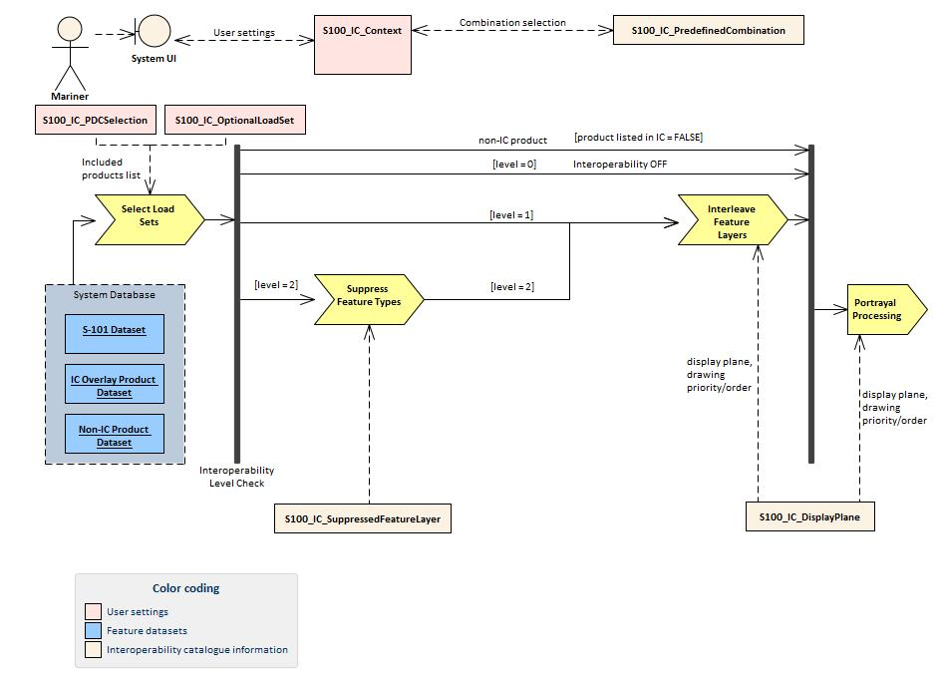

Figure 14‑2. Interoperability processing flow (portrayal processing after interoperability)

For implementations that pass drawing instructions instead of features to interoperability processing, the flow is similar except that portrayal processing takes place before interoperability processing.

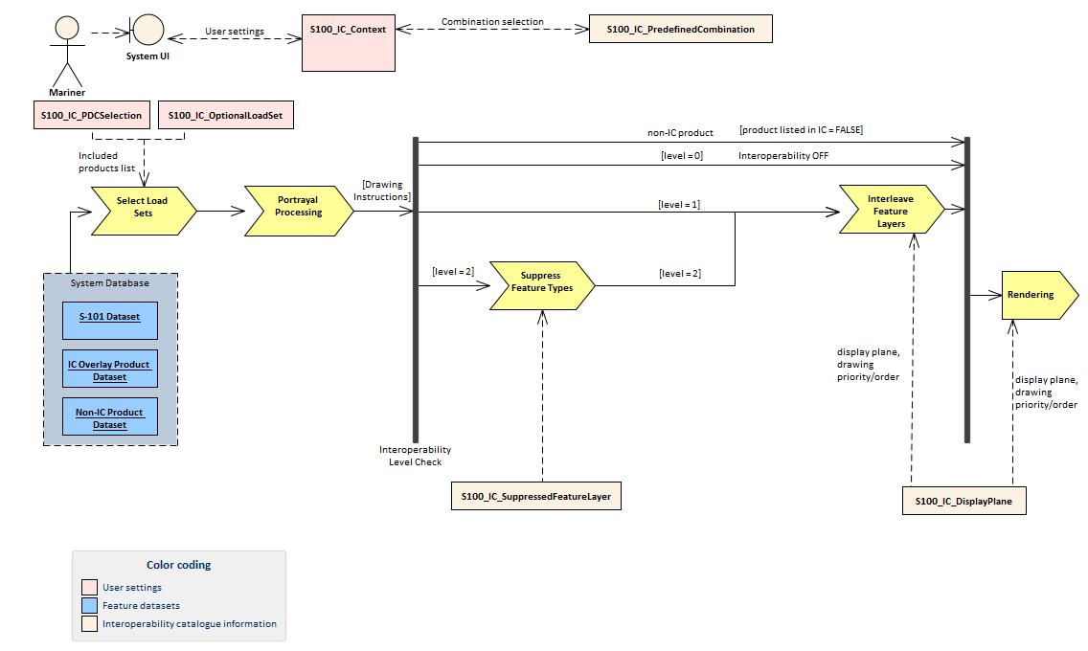

Figure 14‑3. Interoperability processing (drawing instructions generated before interoperability processing)

Table 46. Stages in basic interoperability processing

| **Stage** | **Description** | **Level** | **IC information** | **Context information** | **Remarks** |
| --- | --- | --- | --- | --- | --- |
| Select Load Sets | Select data products to be loaded | All | included product list from S100_IC_‌Predefined‌Combination.‌included‌Product | S100_IC_PDCSelection identifies the S100_IC_‌Predefined‌Combination | - |
| Portrayal Processing | Ordinary S-100 portrayal processing | All | hybrid PC, display planes |  | Except final display processing / rendering |
| Interleave Feature Layers | Assign display plane and drawing order to feature data | 1, 2 | S100_IC_DisplayPlane |  |  |
| Suppress Feature Types | Suppress all instances of a specified feature type in a product | 2 | S100_IC_Suppressed‌Feature‌Layer |  |  |
| Rendering | Display processing | All | S100_IC_DisplayPlane |  |  |

## Processing model for advanced interoperability (Informative)

Figure 14-4 shows the processing steps and input to each step from parts of the interoperability catalogue. The flow depends on the interoperability level selected by the mariner.

As in Basic interoperability, data products to be loaded are selected as specified in the predefined combination selected by the mariner. The mariner may also select additional data products from the optional load set.

The processing of feature data from products not listed in the interoperability catalogue, Levels 0, 1, and 2 interoperability takes place as before.

In Level 3 processing, operations for suppressing feature instances (Suppress Feature Instances) are added, as are operations for hybridization of thematic attributes (Combine Thematic Attributes). Additional processing to adjust feature and information associations for remaining features may be needed and this is done in the “Combine Associations” stage. The order of processing steps is **Suppress Feature Types -‍>Suppress Feature Instances ->Combine Thematic Attributes ->Interleave Feature Layers**.

In Level 4 processing, any additional processing needed to generate spatial primitives for the output hybridized feature is done in the Combine Spatial Attributes stage between suppression of feature instances and combination of thematic attributes. The processing flow is **Suppress Feature Types ->Suppress Feature Instances ->Combine Spatial Attributes ->Combine Thematic Attributes ->Interleave Feature Layers**. It is depicted in the figure below.

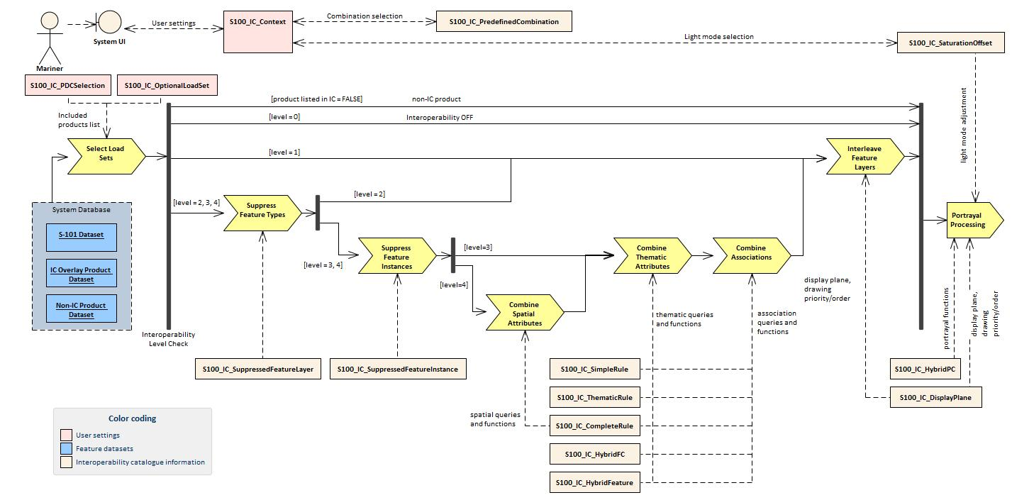

Figure 14‑4. Processing for advanced interoperability (interoperability precedes portrayal)

The processing flow for the other implementation option (drawing instructions precede interoperability) is similar with an additional step (*Portrayal Processing*) moved to immediately follow loading of data.

Table 47. Stages in advanced interoperability processing

| **Stage** | **Description** | **Level** | **IC information** | **Context information** | **Remarks** |
| --- | --- | --- | --- | --- | --- |
| Select Load Sets | Select data products to be loaded | All | included product list from S100_IC_‌Predefined‌Combination.‌included‌Product | S100_IC_PDCSelection identifies the S100_IC_‌Predefined‌Combination | - |
| Portrayal Processing | Ordinary S-100 portrayal processing | All | hybrid PC, display planes |  | Except final display processing / rendering |
| Interleave Feature Layers | Assign display plane and drawing order to feature data | 1, 2, 3, 4 | S100_IC_DisplayPlane |  |  |
| Suppress Feature Types | Suppress all instances of a specified feature type in a product | 2,3,4 | S100_IC_Suppressed‌Feature‌Layer |  |  |
| Suppress Feature Instances | Suppress selected instances of a specified feature type in a product | 3,4 | S100_IC_Suppressed‌Feature‌Instance |  | Applies feature selector expressions encoded in primarySelector and secondarySelector attributes. |
| Combine Thematic Attributes | Select instances for hybridization and generate thematic attributes of a derived feature | 3,4 | S100_IC_SimpleRule, S100_IC_ThematicRule, S100_IC_CompleteRule (L4 only), S100_IC_HybridFeature, S100_IC_HybridFC |  | Selection step skipped if preceded by **Combine Spatial Attributes** (L4 processing) |
| Combine Associations | Adjust associations | 3, 4 | S100_IC_SimpleRule, S100_IC_ThematicRule, S100_IC_CompleteRule (L4 only), S100_IC_HybridFeature, S100_IC_HybridFC |  |  |
| Combine Spatial Attributes | Select instances for hybridization and generate spatial attributes of hybrid feature | 4 | S100_IC_CompleteRule |  | Complete rules incorporate thematic as well as spatial queries and functions. |
| Rendering | Display processing | All | S100_IC_DisplayPlane |  |  |

# User interaction constraints and expectations

## Structured interoperation

Interoperation is expected to be part of a future S-mode as envisaged by IEC and CIRM, i.e., not a “one size fits all” solution but a structured solution that is flexible enough to allow for manufacturer innovation.

## Customization - user level

S-100 compatible ECDIS systems that support the IHO Interoperability Catalogue may include functionality that allow end users (including ship owners, operators, and shipboard officers) to add new predefined combinations according with their needs. These added combinations must not interfere or degrade the official IHO Interoperability Catalogue functions.

## Support Human-Centred Design

As noted in MSC.1/Circ.1512, Human-Centred Design (HCD) helps to ensure that human factors-related knowledge and techniques in system design and development processes are addressed, thus ensuring that user needs and safety are met. Implementers of this standard should perform Usability Testing (UT) and follow the principles stated in MSC.1/Circ.1512 when designing the user interface for interoperability in ECDIS, including the following HCD activities that are carried out to inform development throughout the life cycle:

* Pre-activity: Conduct Early Human Element Analysis (EHEA);
* Activity 1: Understand and specify the context of use;
* Activity 2: Identify the user requirements;
* Activity 3: Produce and/or develop design solutions to meet user requirements;
* Activity 4: Evaluate the design against usability criteria; and
* Activity 5: Maintain operational usability.

Note that fundamental to HCD is the collection of user feedback through UT.

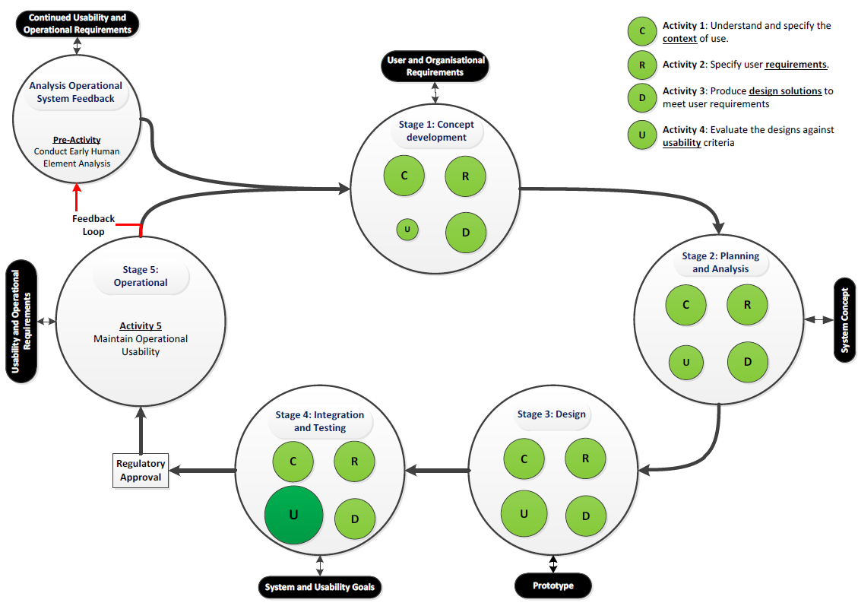

Figure 15‑1. Overview of HCD for e-navigation systems (from MSC.1/Circ.1512)

The details of recommended activities at each stage are found in section 6 of the Annex to MSC.1/Circ.1512.

## Interoperation requirements for product specifications

Responsible parties for product specifications that are included in the interoperability catalogue should consider the impact on the interoperability catalogue and associated product specifications throughout the lifecycle of the product specification. The general principles of Software Quality Assurance (SQA) as found in section 4 of the Annex to MSC.1/Circ.1512. should be applied.

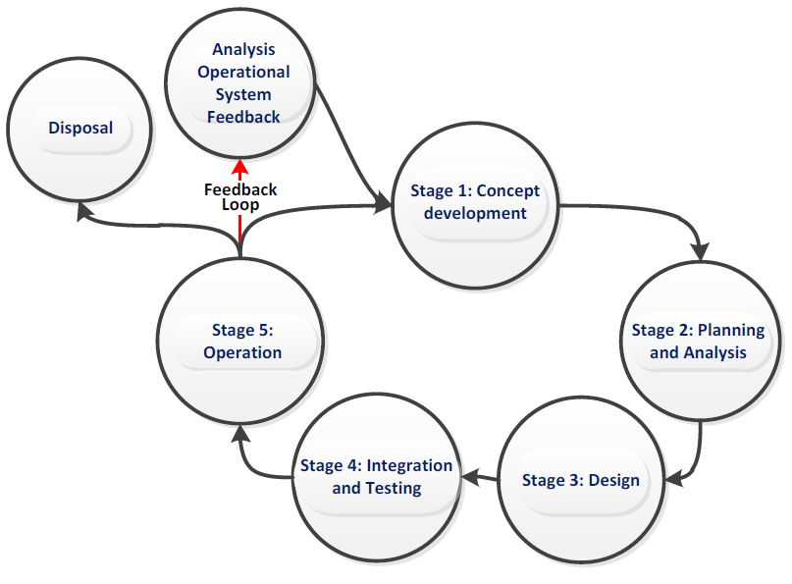

Figure 15‑2. Generic life cycle (from MSC.1/Circ.1512)

Figure 15-2 shows a typical generic life cycle with the stages recommended as a minimum for the management of the development of product specifications that are used with the Interoperability Catalogue:

* Analysis of operational system feedback;
* Stage 1: Concept development;
* Stage 2: Planning and analysis;
* Stage 3: Design;
* Stage 4: Integration and testing;
* Stage 5: Operation; and
* Disposal.

## Support different levels of interoperation

The interoperability catalogue provides support for a fixed set of levels of interoperation, as defined in this document. The progression of levels is from lower to higher levels of implementation complexity and visual integration of products.

## User control over loaded set

Users may load an additional product, or turn off one or more of the data products in a predefined combination.

Data from such additional products which are not mentioned in the interoperability catalogue are treated by the ECDIS according to the priorities and viewing groups encoded in the product’s own portrayal catalogue (e.g., interleaved with layers from products controlled by the interoperability catalogue according to their relative drawing orders and display priorities).

Turning off a data product is treated as if the relevant datasets are not available on the system at all. For example, interoperability rules that are made inapplicable due to one of the data products in their conditions being turned off are ignored.

## User control over interoperation level

The system should allow the user to change the interoperation level and/or pick a predefined combination by means of simple operations. Any options offered to the user must be valid in context, e.g., if the user interface offers the user a choice of predefined combinations at an interoperability level, the listed combinations should be only those defined at that level in the interoperability catalogue.

The system should minimise demands for user interaction when changing interoperability level or predefined combinations, subject to constraints imposed by the platform and interface. Some implications of this guidance are:

1. When the interoperability level alone is changed and the interoperability catalogue contains a predefined combination of the new level that lists the currently displayed product set, the system should apply the rules of the new level to the product set immediately. Alternative predefined combinations for the level may be offered in an unobtrusive way.

EXAMPLE: S-201 and S-101 data are both on-screen when Level 1 is changed to Level 2, and the catalogue includes a “Level 2 S101+S201” predefined combination. Interleaving of S-101 and S-201 features (Level 1) immediately changes to suppression of S-101 navigation aids by S-201 navigation aid features (Level 2). Optionally, a panel on the side of the graphic may display the predefined combinations defined at the new level in the interoperability catalogue.

1. When the predefined combination alone is changed and the interoperability catalogue contains the new predefined combination at the current level, the system should apply the rules of the current level to the new predefined combination.

EXAMPLE: The system is in Level 2 and the S201+S101 predefined combination is changed to S201+S101+S122. The system suppresses S-101 Restricted Area features of type “nature reserve” in favour of Marine Protected Areas from S-122 (assuming the interoperability catalogue contains such a rule).

1. When the interoperability catalogue does not contain a predefined combination at the new level, the user interface should provide an indication of this to the user (though not necessarily by disabling the choice or blocking the transition). Strategies for dealing with this situation are left to interface designers. For example, systems may offer to use the closest fit in the interoperability catalogue with any residual on-screen products as ordinary overlays.

## Priority overrides for user-specified settings

Where user action amends a setting, which then conflicts with a system setting, the user setting should override the system setting.

EXAMPLE: Feature display priority set by a user should override display priority set in the interoperability catalogue or portrayal catalogue.

# Data Encoding Guide

## Introduction

This section contains encoding guidance on syntax, content, and catalogue structure for interoperability catalogue developers. Guidance on how to make product specifications interoperable and what principles to apply when developing an interoperability catalogue is provided in Section 8. For definitions of catalogue elements, their attributes, and associations, refer to Section 4.

## General encoding notes

### Identifiers and references

Several catalogue elements have an *identifier* attribute. The value of this attribute must conform to the syntax for a Uniform Resource Identifier (URI). This means it may be a URL, an integer, alphanumeric character string without whitespace, or a URN (the effects of introducing MRNs in future editions of S-100 are TBD). Any additional restrictions are mentioned in the encoding notes for the appropriate element, which make up the rest of this section.

Some catalogue classes in the application schema (section 4.3) have associations that act as references to the element at the other end of the association. This is encoded in the data format as an XML child element of the referrer, whose XML tag is the same as the role name in the UML model. The value of such a reference must be equal to the value of the *identifier* attribute of the referenced element.

EXAMPLE:

The tag <featureRef>urn:mrn:iho:s111:1.0:CURENT</featureRef> in an S100_IC_SuppressedFeatureLayer element is a reference to the S100_IC_Feature element with tag

<identifier>urn:mrn:iho:s111:1.0:CURENT</identifier>.

### Feature codes

Some catalogue elements have a *featureCode* attribute. The value of attribute *featureCode* must be the camel case code of the feature as encoded in the feature catalogue for the product named in the *product* co-attribute.

## Unknown Attribute Values

When a mandatory attribute code or tag is present but the attribute value is missing, it means that the producer wishes to indicate that this attribute value is unknown. Missing mandatory attributes must be “nilled”. Optional attributes must be omitted altogether if the value is unknown or missing. They must not be “nilled”. This rule also applies to metadata.

## Element S100_IC_DisplayPlane

A S100_IC_DisplayPlane element must contain at least one instance of S100_IC_DrawingInstruction or S100_IC_Feature. It may contain multiple instances of either or both. The choice depends on whether symbols or other components of drawing instructions are being substituted.

The *name* and *description* attributes should be populated with text values that indicate the purpose and feature content of the plane to people developing, configuring, or using interoperability catalogues, including hydrographers and navigation officers.

## Element S100_IC_DrawingInstruction

Drawing instruction elements in the feature catalogue override the drawing instructions generated directly from the data product’s portrayal catalogue. Details of this overriding are described in section 4.4.2.6.

The attributes *product*, *featureCode*, *geometryType*, and *attributeCombination* values together make up a filter condition determining the subset of instances of a feature type to which the drawing order and viewing group encoded in S100_IC_DrawingInstruction apply. They are to be applied in conjunction (“AND”) – that is, the S100_IC_DrawingInstruction’s viewing group and drawing order apply only when the conditions expressed by all these attributes are satisfied. (Attributes *geometryType* and *attributeCombination* being optional are ignored if not encoded.)

If an instance of **S100_IC_DisplayPlane** contains both **S100_IC_Feature** and **S100_IC_DrawingInstruction** elements with the same “filter condition”, their drawing order and viewing group must also be the same.

Features (drawing instructions) not satisfying a filter condition in an instance of S100_IC_DrawingInstruction are treated according to any other interoperability rules which may apply to them, or if none, they treated according to the data product’s portrayal catalogue.

Distinction: S100_IC_Feature

## Element S100_IC_Feature

S100_IC_Feature elements in the feature catalogue override the drawing order and viewing group in the data product’s portrayal catalogue. Details of this overriding are described in section 4.4.2.6.

S100_IC_Feature elements have the same four filter condition attributes as s100_IC_DrawingInstruction and the same rules and constraints described in section 16.5 apply.

Distinction: S100_IC_DrawingInstruction

## Element S100_IC_InteroperabilityCatalogue

Any product mentioned in any attribute of type *dataProduct* of a catalogue element (e.g., **S100_IC_Feature.***product*, **S100_IC_PredefinedCombination.***includedProduct*, etc.) must be mentioned in a *productCovered* attribute of this element.

The attribute *productCovered* will be used by the ECDIS in deciding whether to apply interoperability rules or fall back on ordinary overlay portrayal and therefore all products taken into account when developing the catalogue must be listed.

The *name*, *description,* and *requirementDescription* attributes should be populated with text values of appropriate size that are meaningful to people developing, configuring, or using interoperability catalogues, including hydrographers and navigation officers. These attributes, especially *requirementDescription,* will potentially be displayed to navigation and bridge officers when they select an interoperation catalogue for a particular phase of a voyage, and should be populated with this use in mind.

## Element S100_IC_DisplayPlane

As mentioned in the encoding notes for S100_IC_Feature and S100_IC_DrawingInstruction, an instance of this element must contain at least one of S100_IC_Feature or S100_IC_DrawingInstruction.

## Element S100_IC_PredefinedCombination

Attribute *includedProduct* must be populated with all data products referenced directly or indirectly in this predefined combination, including:

* the *product* attribute of a S100_SuppressedFeatureLayer contained in this element;
* the *product* attribute of a S100_Feature or S100_IC_DrawingInstruction referenced by an S100_IC_SuppressedFeatureLayer element contained in this element.

The *name*, *description,* and *useConditions* attributes should be populated with text values of appropriate size that are meaningful to people developing, configuring, or using interoperability catalogues, including hydrographers and navigation officers. These attributes, especially *useConditions,* will potentially be displayed to navigation and bridge officers when they select an interoperation catalogue for a particular phase of a voyage, and should be populated with this use in mind.

## Element S100_IC_SuppressedFeatureLayer

The *featureCode* and *product* attributes identify a feature type which will be suppressed in its entirety, i.e., all instances of the feature from that product will be hidden. They will be replaced by instances of the feature type and product indicated by the referenced S100_IC_Feature (or S100_IC_DrawingInstruction). Both elements may include conditions pertaining to attribute values and geometry type, as described in section 16.5. The implications should be carefully considered when referencing instances of S100_IC_Feature or S100_IC_DrawingInstruction, for example:

* Whether all feature instances of the indicated feature type from the replacing product will be displayed, or only a subset selected by attribute values. What happens to the excluded instances – should they be displayed or not? (Note that the model allows replacement of one feature type by multiple feature subsets, e.g., an S-101 Ice Area may be replaced by multiple ice features from S-412).
* Whether the spatial attributes change and if so is this desirable? For example, does the replacing product include features of both point and surface while the replaced product includes only point features?

# Normative Implementation Guidance

## Reduce demand on user attention - display adjustment

Provide for the use of decluttering techniques by implementations, such as minimizing overlaps of both symbols and text, minimization of the number of colours on the display.

## Reduce demands on user attention - avoid text overload

Provide for text to be shown separately from graphic display. Provide for limiting the amount of text shown both in-graphic, over-graphic, and in a separate auxiliary display.

Generally, in-line text is shorter than text from a support file, though some specifications (S-101) allow as many as 300 characters.

Generally speaking interoperability catalogue developers should review what individual DCEGs say and what portrayal catalogues do with text attributes, since the product specification developers can be expected to know which attributes can be expected to contain long text and which contain short text.

## Support for novice users

Allow implementations to have "novice" modes or user interface controls, which provide shortcuts for inexperienced users.

## Reduce demands on user attention - planning and monitoring modes

Planning mode can be allowed to provide more powerful information search or processing functionality at the expense of more user attention.

Route monitoring mode must support the ECDIS showing the information required for monitoring while allowing bridge officers to focus on other tasks.

## Interoperability and data coverage

The interoperability rules and interleaving operations described in an interoperability catalogue apply only in areas where the products referenced in the rule or interleaving operation have data coverage at the current display scale on the navigation system.

If data coverage for some of the products in the selected predefined combination is absent in an area, the rules and interleaving operations referring to products which do have data coverage in the area in question will continue to apply in that area. Rules and interleaving operations referring to products which do not have data coverage in the area will not apply in the area in question.

Implementations should be capable of indicating parts of the display screen where (a) interoperability is partially applicable because some of the data products in a predefined combination do not have data coverage while others do have coverage; (b) interoperability is not applicable at all because the data products in the selected predefined combination do not have coverage (or the only coverage is that of the base S-101 layer).

Note (informative): Depiction and symbols for such distinguished parts of the screen is a matter for ECDIS performance standards but an off-graphic message on the ECDIS, or an adaptation of overscale warning symbology may be suitable.

## Other significant information

The inclusion in interoperability catalogues of data products whose interoperability has not been discussed with product specification development team is recommended against.

There should be a dialogue between interoperability teams and product specification teams, so that new changes to product specifications are ensured to be covered by interoperability catalogues.

Feature catalogue and portrayal catalogue development teams are stakeholders for hybrid catalogues.

Product specifications that are in scope of the interoperability catalogue should have at least ten display priority steps between display groups, in order to allow more flexibility in interleaving with other products.

## Phased implementation

Implementation of interoperability is planned in two phases.

1. Phase 1: Levels 1 and 2 constructs.
2. Phase 2: Levels 3 and 4 constructs.

For this version of the specification, only implementation of Phase 1 is envisaged. Implementation of Phase 2 is placed on hold until further notice.

# Interoperability Catalogue Schema Documentation

Detailed documentation for the XML schema is provided in a separate document.

# Feature Catalogue

[Documentation for the hybrid feature catalogue will be added when it is defined.]

# Portrayal Catalogue

[Documentation for the hybrid portrayal catalogue will be added when it is defined.]

1. More expressive filter expressions can be developed if required for advanced interoperability.